[What is Patchs Translate? – PATCHS Support](https://help.patchs.ai/hc/en-gb/articles/1500002227881-What-is-Patchs-Translate)

<https://help.patchs.ai/hc/en-gb/articles/1500002227881-What-is-Patchs-Translate>

**Below is a summary about Patchs Translate.**

**More details are in the link above**

**What is Patchs Translate?**

Patchs Translate is to help people who do not speak English as their first language to communicate with their GP. It will not replace talking to someone.

If you are not sure about the translation, please contact the practice.

**How to use Patchs Translate**

**To translate the text**, select the language you want from the drop-down menu:

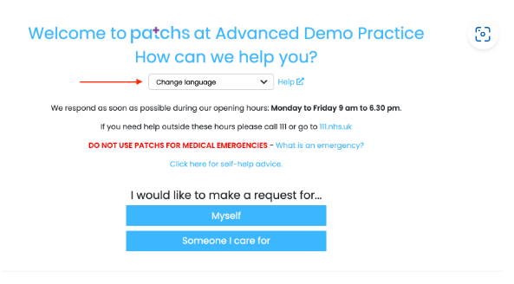

Patchs can’t guarantee the translation is 100% accurate, so you will get a warning message.

**When we send you a message**, it will first be displayed in English.

You can translate it to your chosen language by selecting it from the drop-down menu at the top of the page:

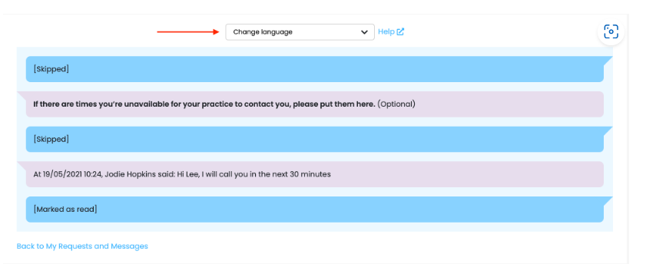

# What technology is used?

Translations are provided by Amazon, though they do not store or view your data. If you do not feel comfortable with this you should not use Patchs Translate.