**Contacting your practice via the NHS App**

To contact your GP practice via the NHS App, follow the steps below.

*Please note that not all GP practices have enabled Patchs access via the NHS App.*

*If you know your GP practice is using Patchs, but cannot see Patchs when completing the steps below, please contact your practice directly to check whether or not they have enabled NHS App access.*

**Asking for help for a medical issue via the NHS App**

To contact your practice for help with a medical issue, load the NHS App and then choose **Services**from the lower left of the screen. Select **Contact your GP about a health problem.**

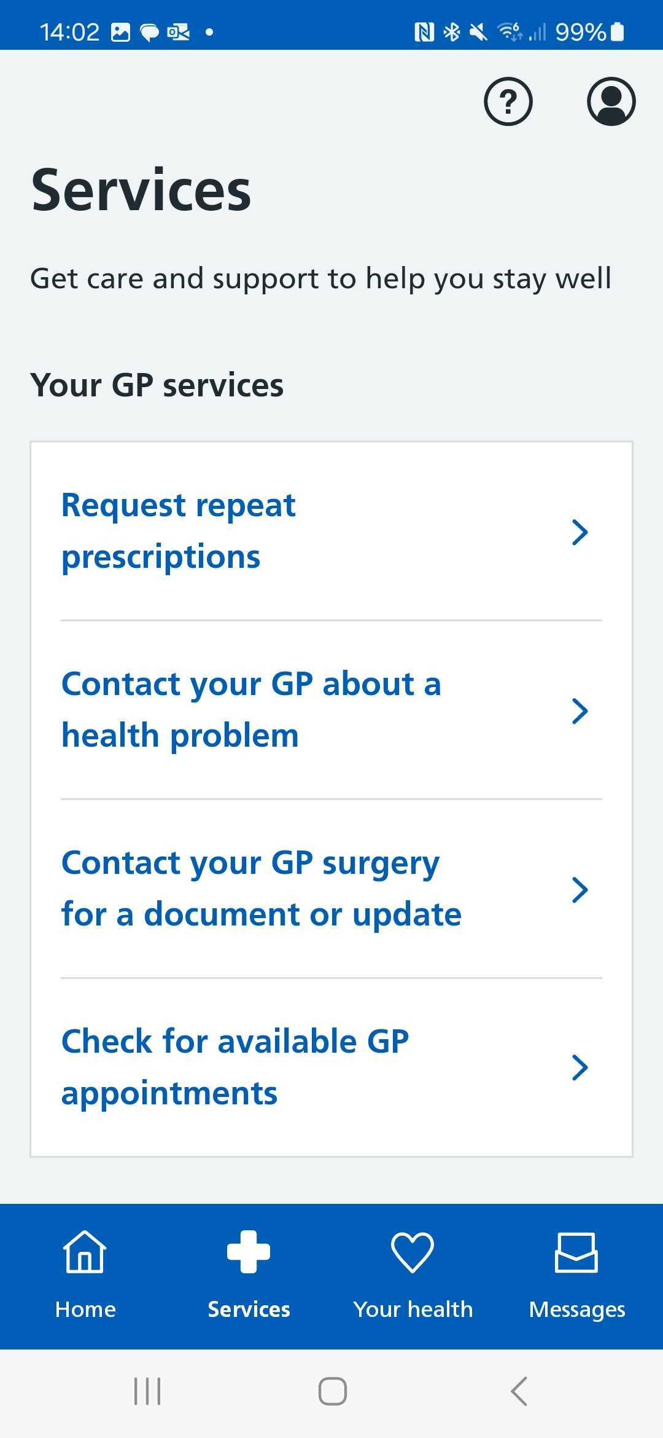

Then select **Continue**to access Patchs:

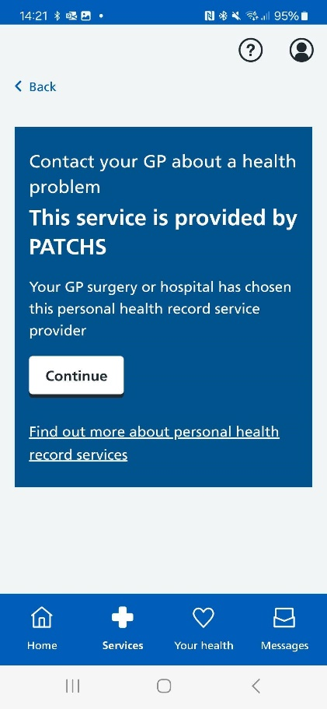

Then choose either: 

* + **New health problem**- for something you haven't contacted your GP practice about before.
  + **Ongoing health problem** - for something your GP practice already knows about.

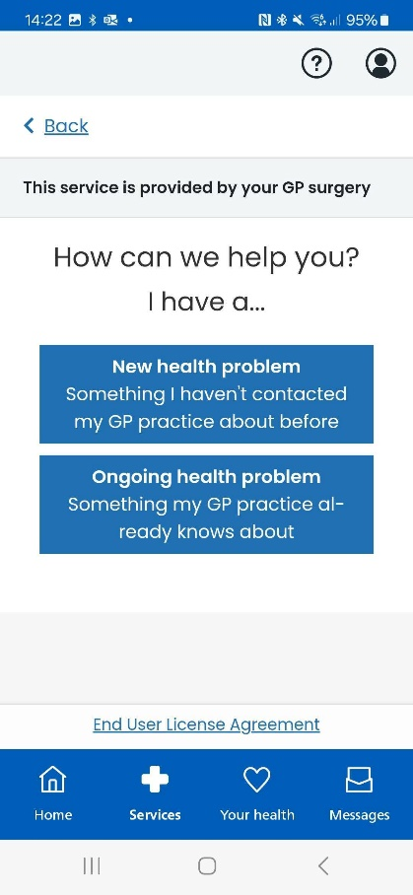

Having chosen your request type, you will need to answer a few questions. Click **Next** to submit your answer to each question.

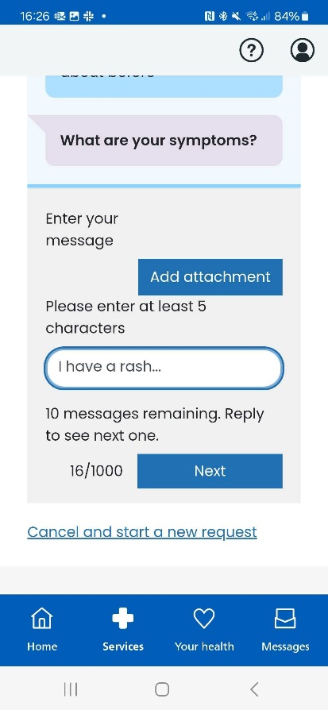

When you have answered all the questions, click **Next** to proceed.

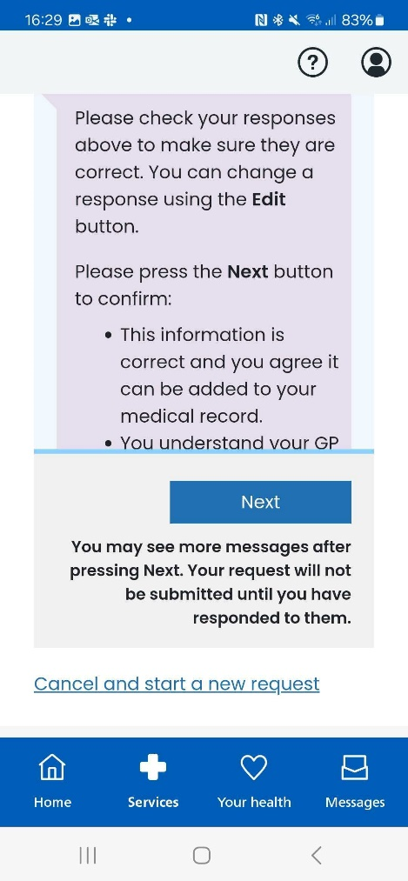

Once you have successfully submitted your request you'll be taken to a confirmation page.

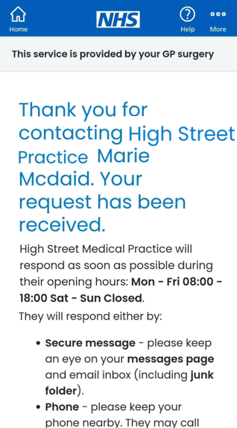

**Asking for help with an admin query via the NHS App**

To contact your practice for help with an admin query, load the NHS App and then choose **Services** from the bottom of the screen. Select **Contact your GP surgery for a document or update** (the third option).

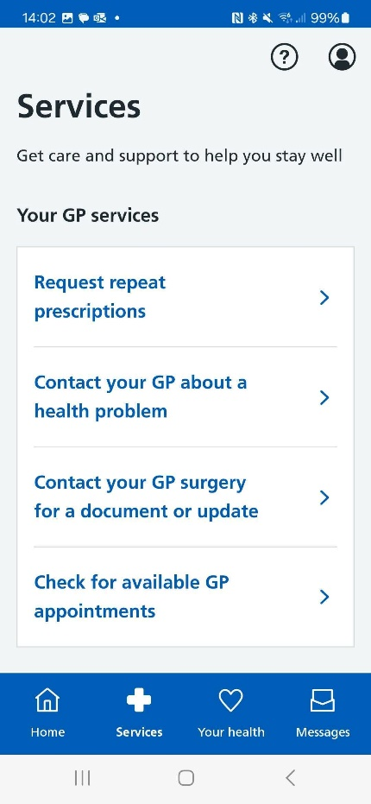

Click **Continue**to access Patchs.

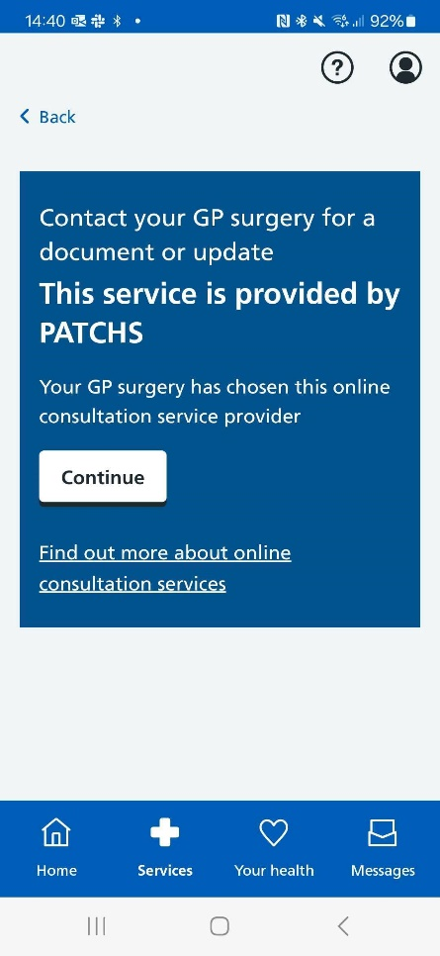

Having chosen to **Contact your GP surgery for a document or update**, you will need to answer a few questions. Click **Submit** to submit your answer to each question.

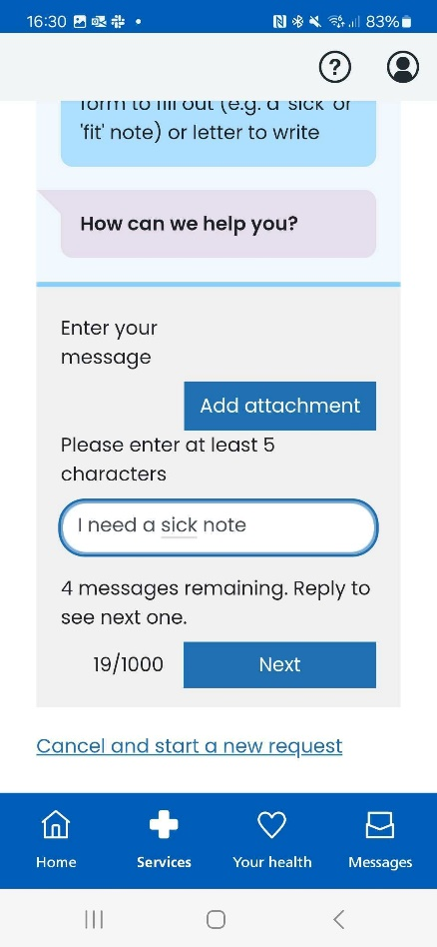

When you have answered all the questions, click **Next** to proceed.

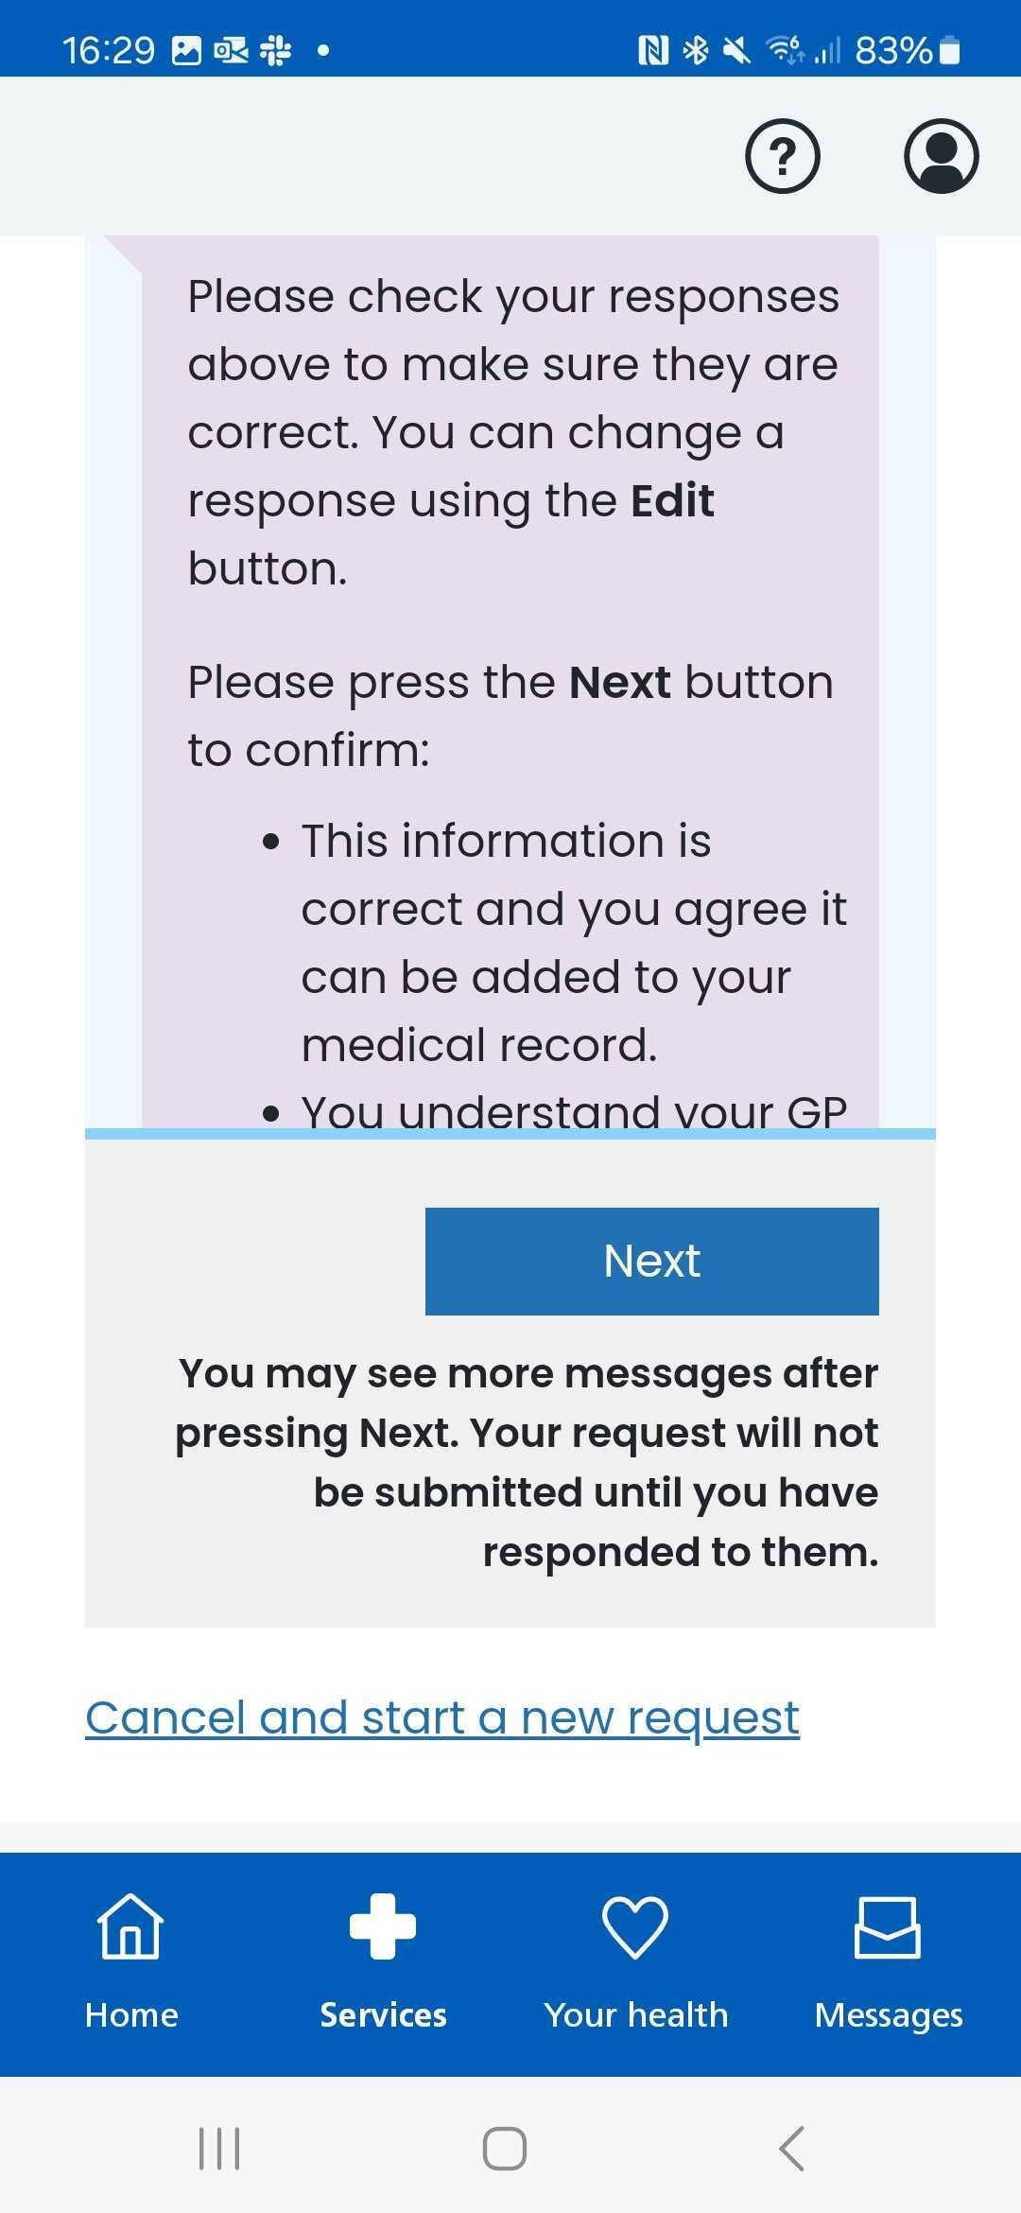

Once you have successfully submitted your request, you'll be taken to a confirmation page.

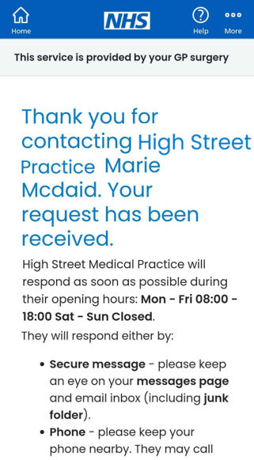

**Reading and responding to a Patchs message via the NHS App**

To read and respond to a Patchs message, load the NHS App and then choose **Messages** from the lower right of the screen.

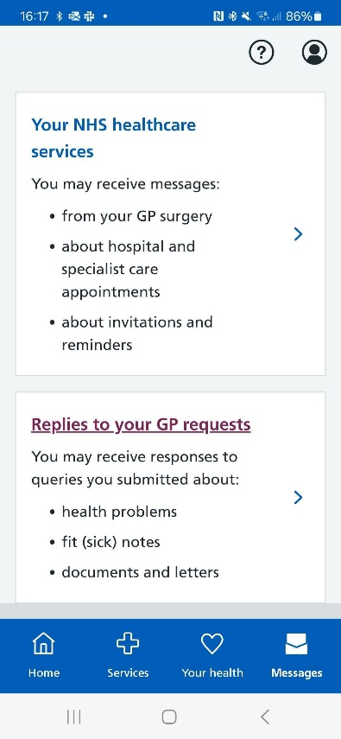

Select **Replies to your GP requests**.

You will then be taken to **My Requests and messages,**where you can view your past requests and respond to any messages.

