# Resetting your Password

If you forget your password or think that it may no longer be secure, you can reset it. This article explains how to reset your password if you usually login:

1. [using a Patchs account](https://help.patchs.ai/hc/en-gb/articles/360058755473-Resetting-your-Password#h_01HCA3DH6Q0C6VQE3CZCXMTJDH)
2. [using NHS Login](https://help.patchs.ai/hc/en-gb/articles/360058755473-Resetting-your-Password#h_01HCA2KMK7N5YDSA3HV060DX4C)

## How to reset your password if you usually login using a Patchs account

* When you try to login on the **Patchs Welcome**page, you will be prompted to enter your password as normal.
* As you wish to reset your password, do not fill in any information. Instead, click on the **I've forgotten my password** link to the right of the Login button.

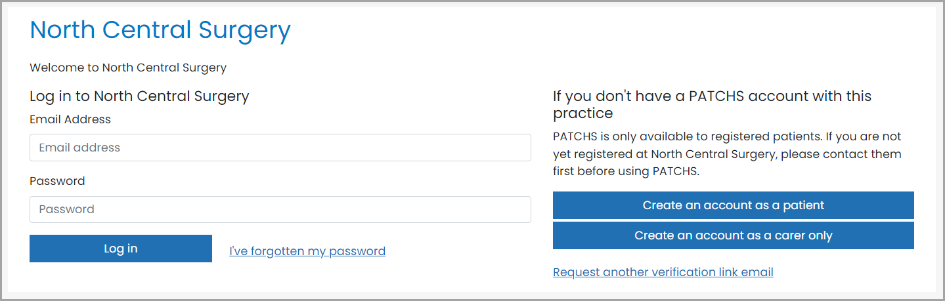

* You will be taken to a message which asks you to enter your email address, so that we can send you a link to reset your password.
* Please enter the email address you used to register with Patchs.
* Click the **Submit**button.

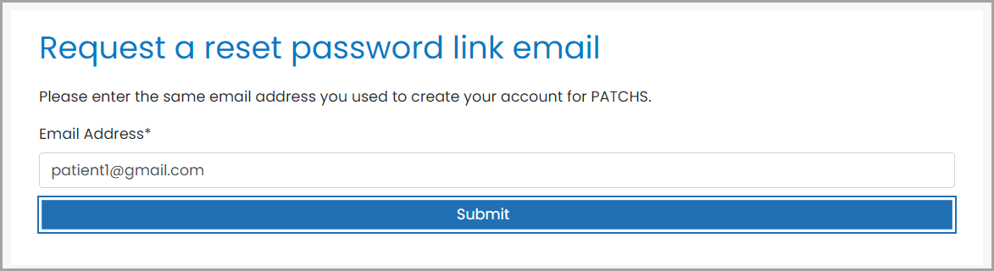

* A message will then appear confirming that a reset password email has been sent to your registered email address.

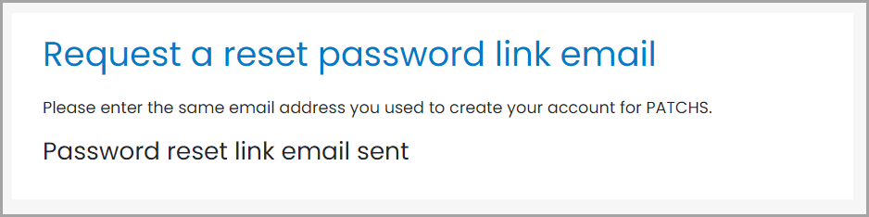

Please note that if you try to reset your password in this way when you normally login using NHS login, a reset password email will not be sent, and you will not see this message. Instead, you will be redirected to NHS Login, and should follow [*the instructions further down*](https://help.patchs.ai/hc/en-gb/articles/360058755473-Resetting-your-Password#h_01HCA2KMK7N5YDSA3HV060DX4C) this article.

* Look for the reset password email in your email inbox (please check your Junk folder if you do not see it).
* The email will contain a **password reset link** that is valid for 24 hours.
* Click on the link.

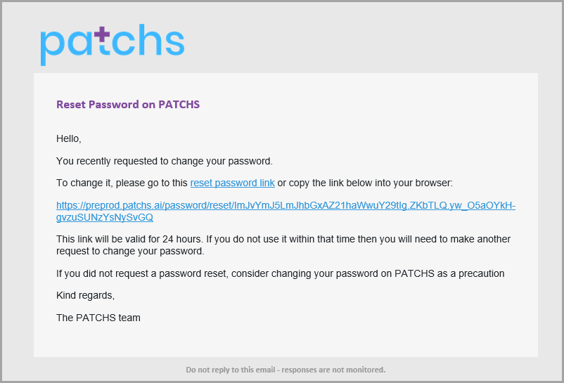

* You will be taken to the **Reset password**page. Here, you should enter and confirm your new password.
* Your password must be at least 12 characters and contain uppercase and lowercase letters and numbers.

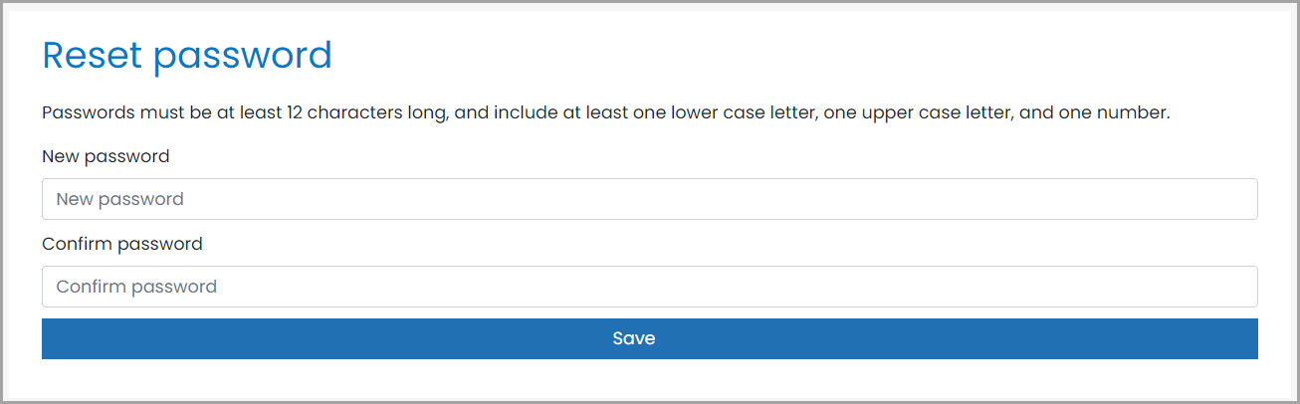

* Once your password has been changed you will receive a confirmation message.
* You can now log into Patchs using your registered email address and new password.

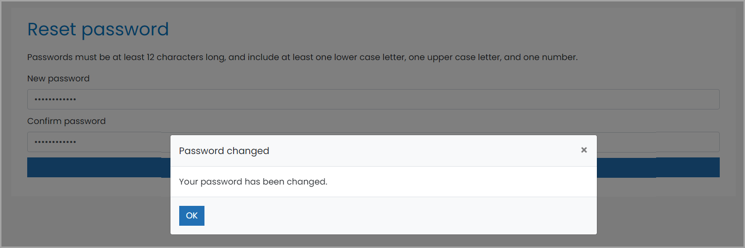

## 

## How to reset your password if you usually login using NHS Login

1. Go to your GP Practice's website and click on the **Continue with NHS** login button:

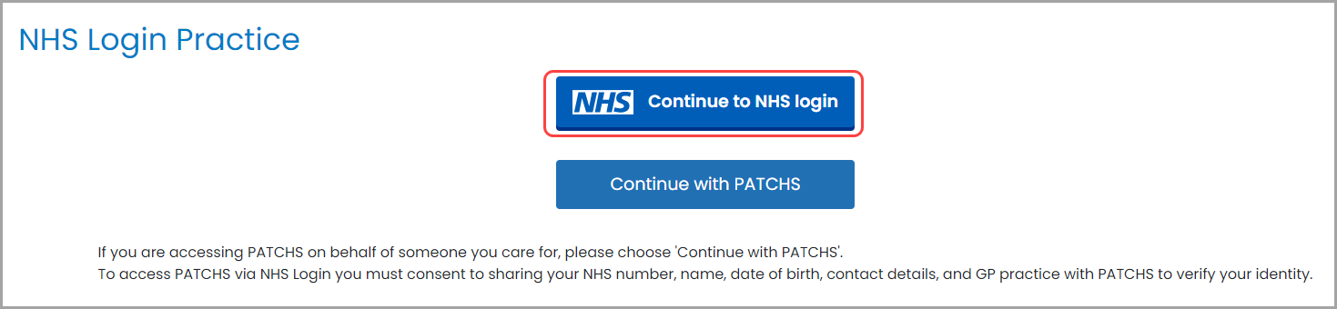

2. You will be taken to the NHS login page, where you should enter your email address. Now click **Continue**.

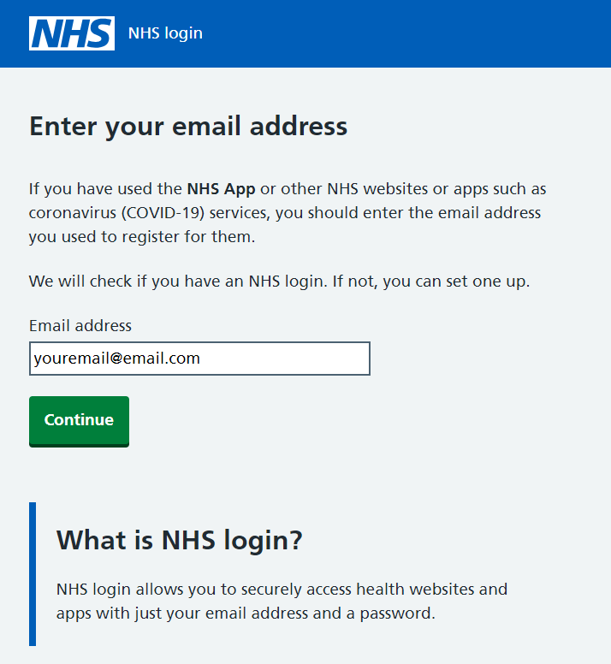

3. You will now be prompted to enter your password. However, as you wish to reset your password, leave the box blank. Instead, click on the link below which invites you to **reset it**.

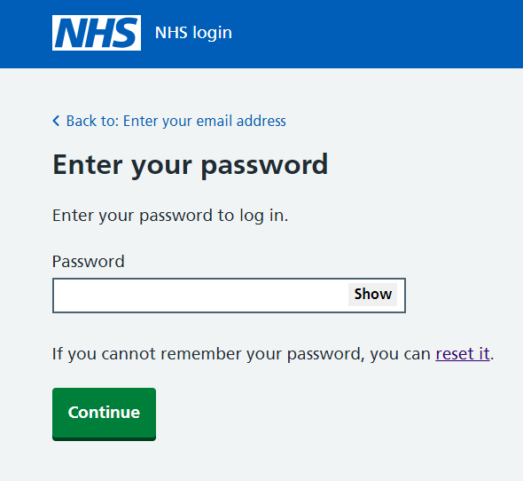

4. NHS login will now guide you through how to reset your password. Once you have completed the steps, you can return to Patchs and login using your new password.