**Contacting your GP for someone else**

This explains how to submit a request for help to your GP practice for someone you care for. The person you are submitting the request for must be:

1. registered at the same practice as yourself, and
2. you must be registered as their carer.

*Please note, you must not use Patchs for medical emergencies.*

**How to contact your GP on behalf of someone else**

Once you are registered ([see here](https://help.patchs.ai/hc/en-gb/articles/360058753273)) and logged into Patchs ([see here](https://help.patchs.ai/hc/en-gb/articles/360056868154)), click on the **Make a Request**link at the top of the page.

This will load the **How can we help you?**page, where you need to click the **Someone I care for**button.

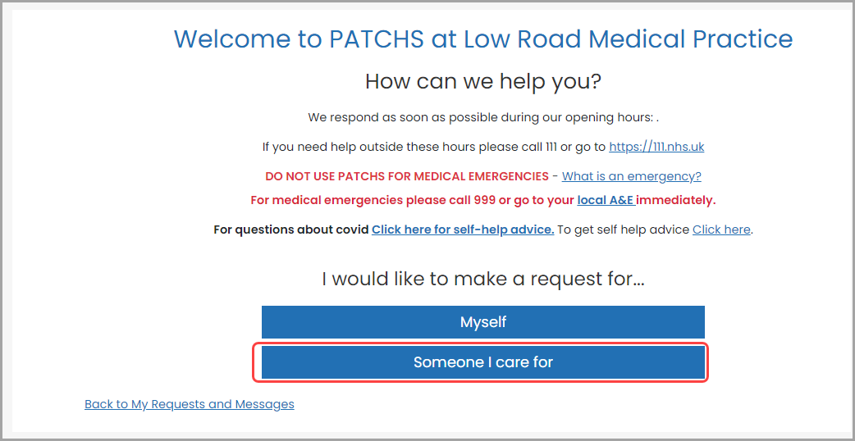

You will now be taken to the **Choose Dependent**page.

Here, choose a dependent from a list (if they have already been set up). If they have not been set up, you can add someone new by clicking on the **Add someone I care for**link.

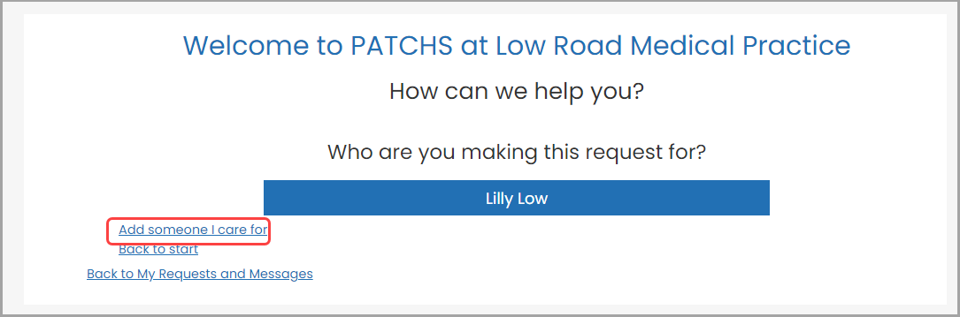

Clicking the **Add someone I care for** link takes you to the **Add Dependents**page.

Here, you will be able to enter the details of the person you are caring for. You will need to confirm (i) that this person is registered at this GP practice, and (ii) that you are authorised to act in the capacity of parent or carer for this person. Do this by checking the boxes at the bottom of the page.

When you have finished, click the **Add**button.

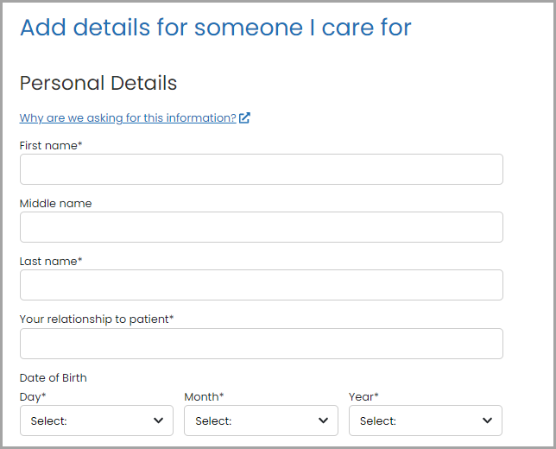

Now select the dependent from the **Choose Dependent**page.

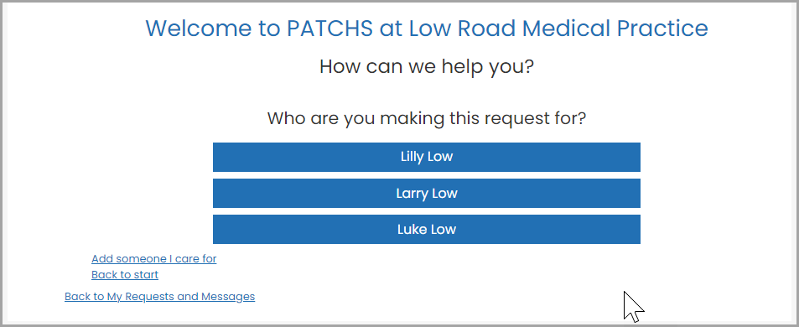

This will take you to the **Request Contact**page, where you can click on the button that best describes your type of request.

