**Contacting your practice via the NHS App**

**Asking for help for a medical issue via the NHS App**

To contact the practice for help with a medical issue, load the NHS App and then:

1. Choose**Services**from the lower left of the screen
2. Select **Contact your GP about a health problem**
3. Then select **Continue**to access Patchs
4. Then choose either:   
   * **New health problem**- for something you haven't contacted your GP practice about before.
   * **Ongoing health problem** - for something your GP practice already knows about.

Having chosen your request type, you will need to answer a few questions and confirm your answers to submit your request.

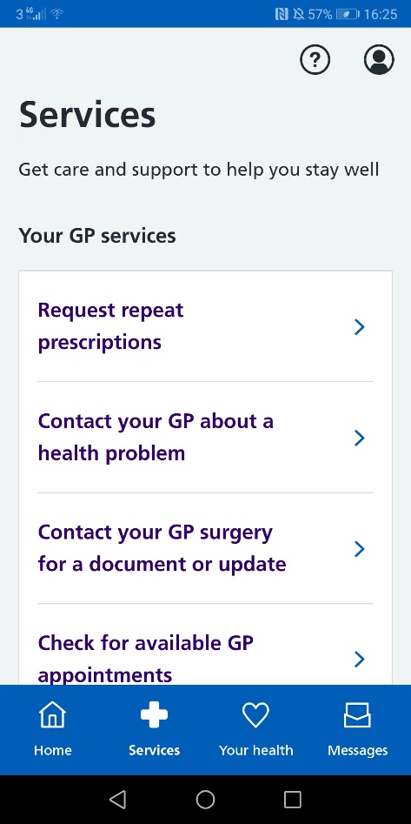

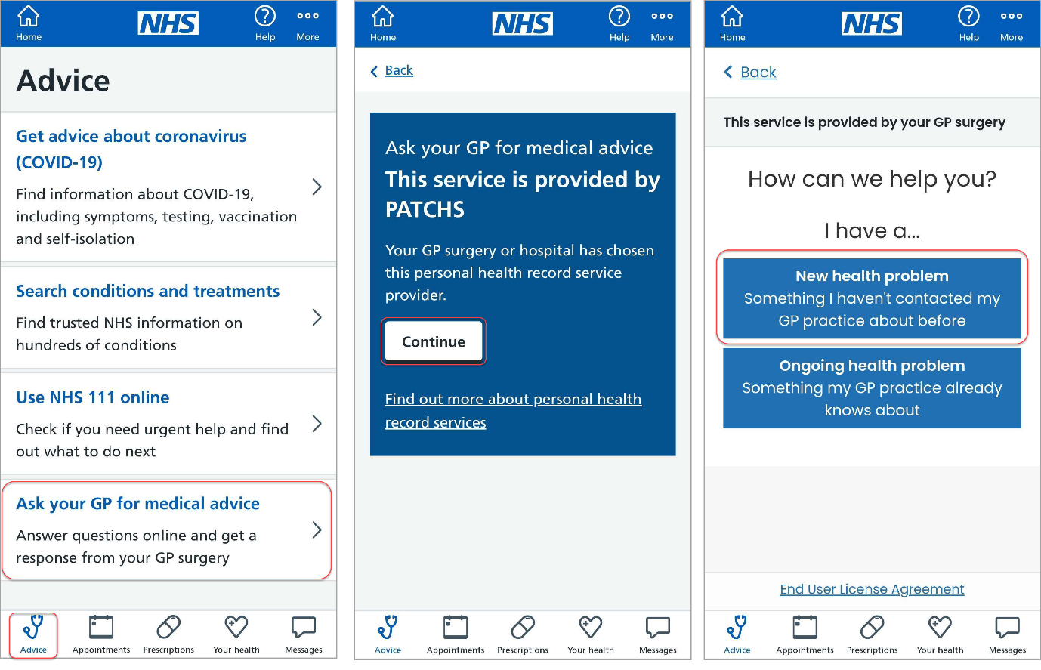

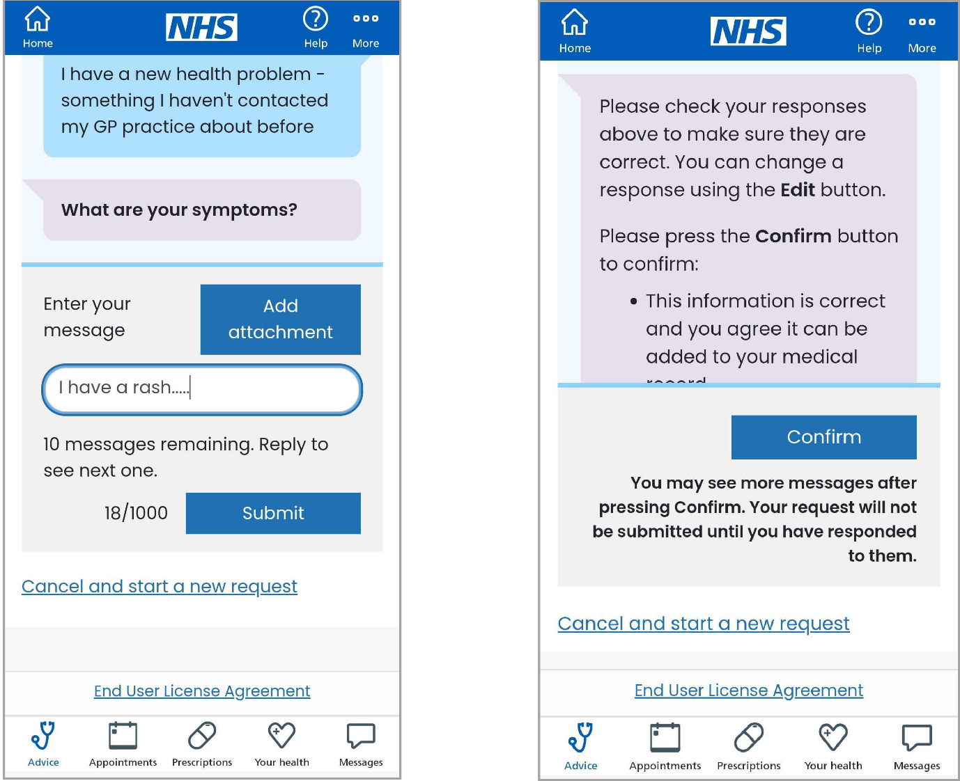

Once you have successfully submitted your request you'll be taken to a confirmation page.

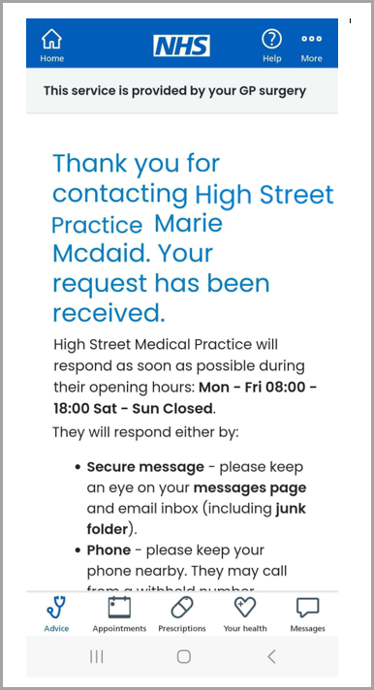



**Asking for help with an admin query via the NHS App**

To contact the practice for help with an admin query, load the NHS App and then:

1. Choose **Messages** from the lower left of the screen
2. Select **View responses, check your past requests or send a new request**
3. Click **Continue**to access Patchs
4. Choose **Ask for a fit note (sick note), or other documents**to submit an admin query.

Having chosen to ask your GP practice a question, you will need to answer a few questions and confirm your answers to submit your request.

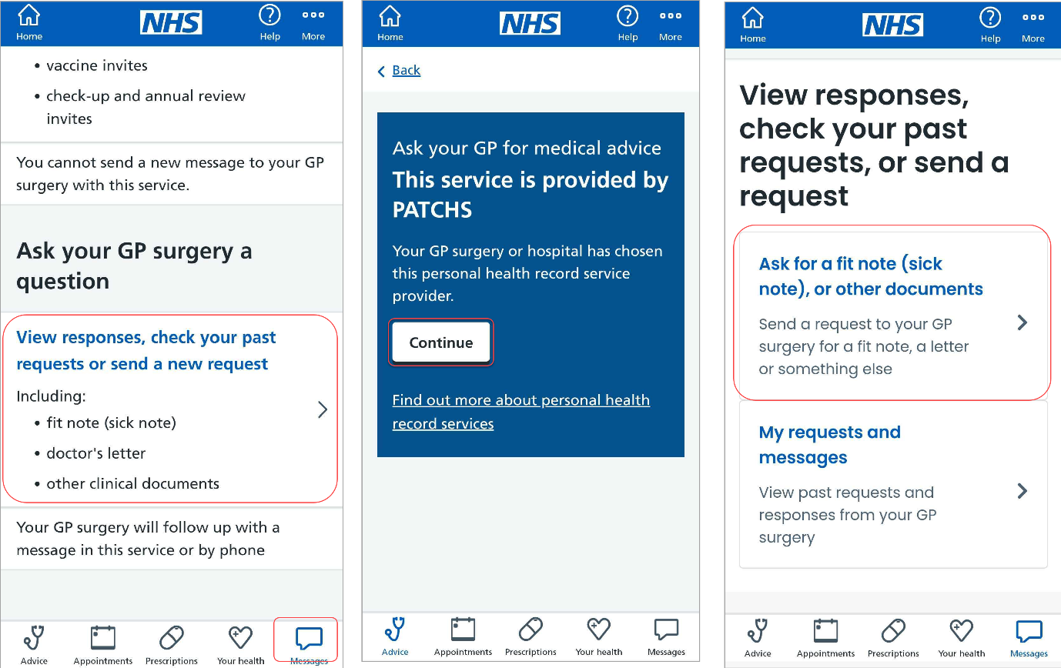

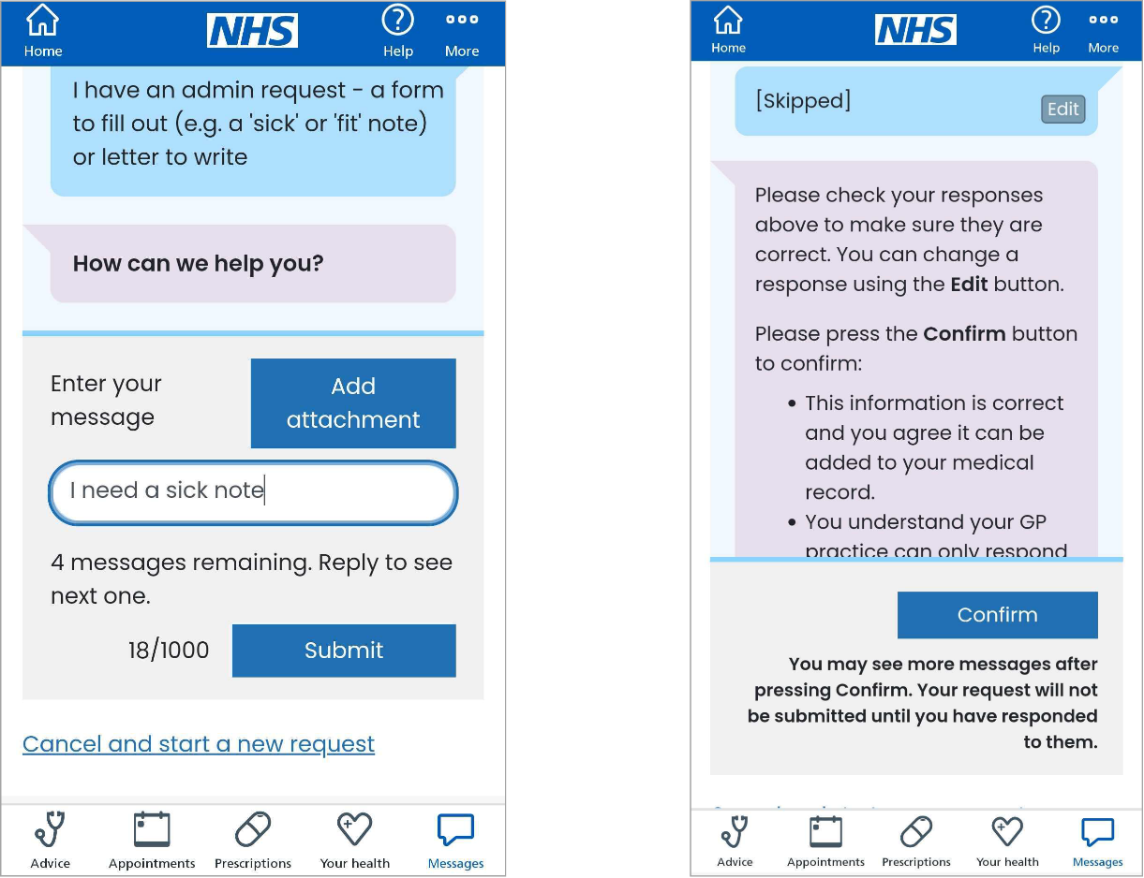

Once you have successfully submitted your request, you'll be taken to a confirmation page.



**Reading and responding to a Patchs message via the NHS App**

To read and respond to a Patchs message, load the NHS App and then:

1. Choose **Messages** from the bottom left of the screen
2. Select **View responses, check your past requests or send a new request**
3. Click **Continue**to access Patchs
4. Choose **My requests and messages**to view past requests and responses from your GP practice

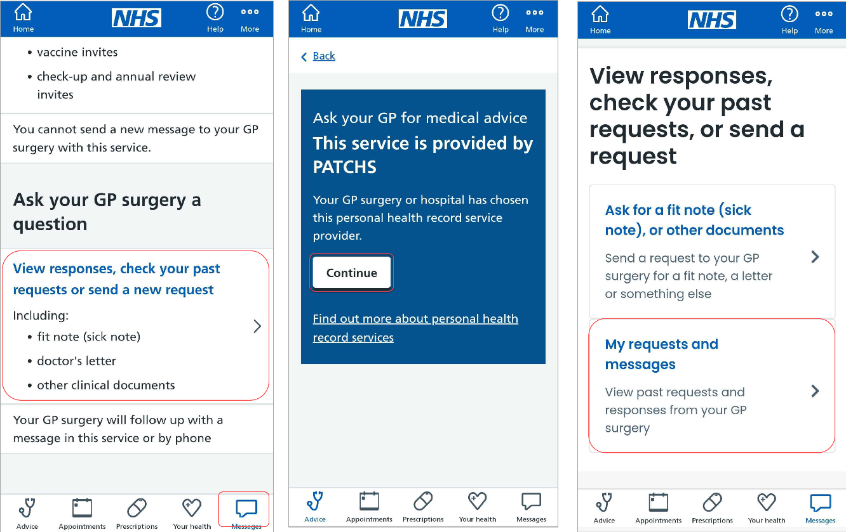You will then be taken to **My Requests and messages,**where you can view your past requests and respond to any messages.

