**Contacting your GP for Someone Else**

This article explains how to submit a request for help to your GP practice for someone you care for. The person you are submitting the request for must be:

1. registered at the same practice as yourself, and
2. you must be registered as their carer.

*Please note, you must not use Patchs for medical emergencies.*

**How to contact your GP on behalf of someone else**

Once you are registered and logged into Patchs, click on the **Make a Request**link at the top of the page.

This will load the **How can we help you?**page, where you need to click the **Someone I care for**button.

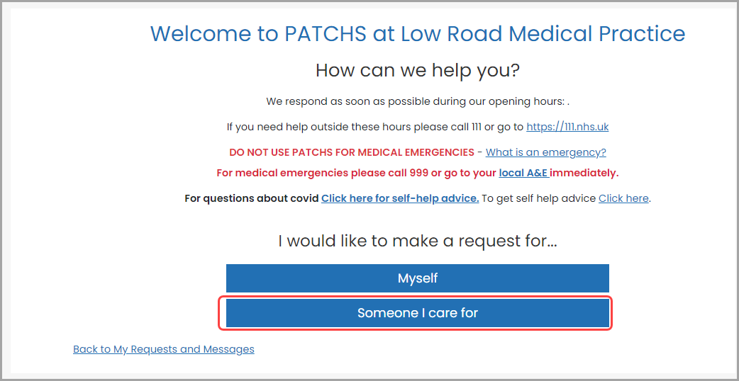

You will now be taken to the **Choose Dependent**page.

Here, choose a dependent from a list (if they have already been set up). If they have not been set up, you can add someone new by clicking on the **Add someone I care for**link.

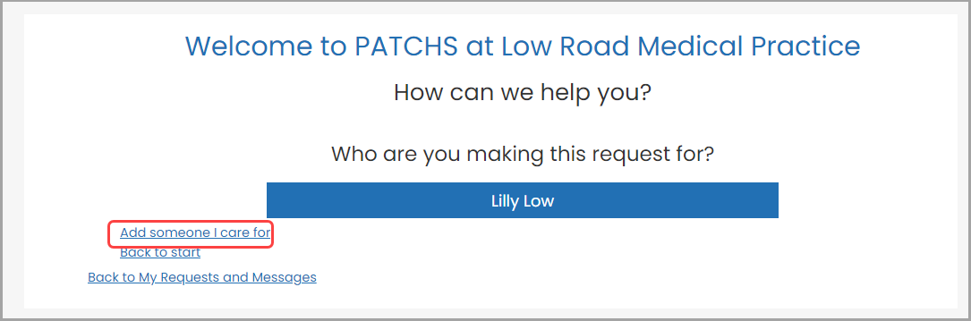

Clicking the **Add someone I care for** link takes you to the **Add Dependents**page.

Here, you will be able to enter the details of the person you are caring for. You will need to confirm (i) that this person is registered at this GP practice, and (ii) that you are authorised to act in the capacity of parent or carer for this person. Do this by checking the boxes at the bottom of the page.

When you have finished, click the **Add**button.

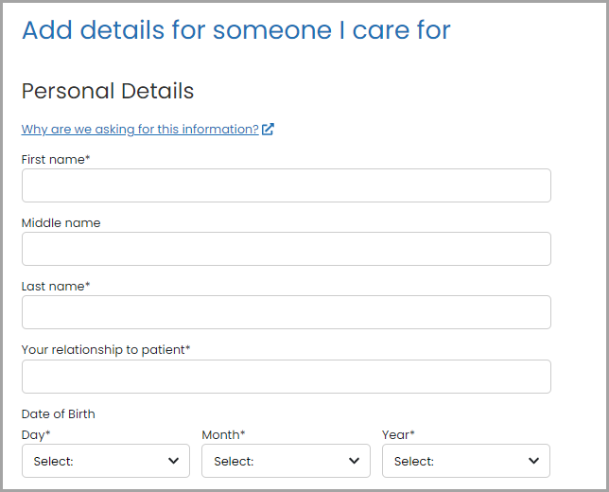

Now select the dependent from the **Choose Dependent**page.

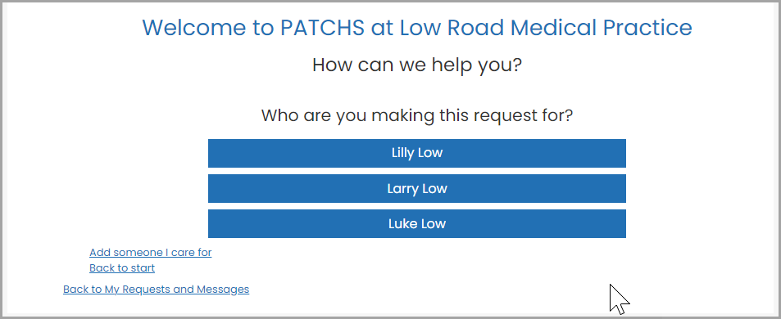

This will take you to the **Request Contact**page, where you can click on the button that best describes your type of request.

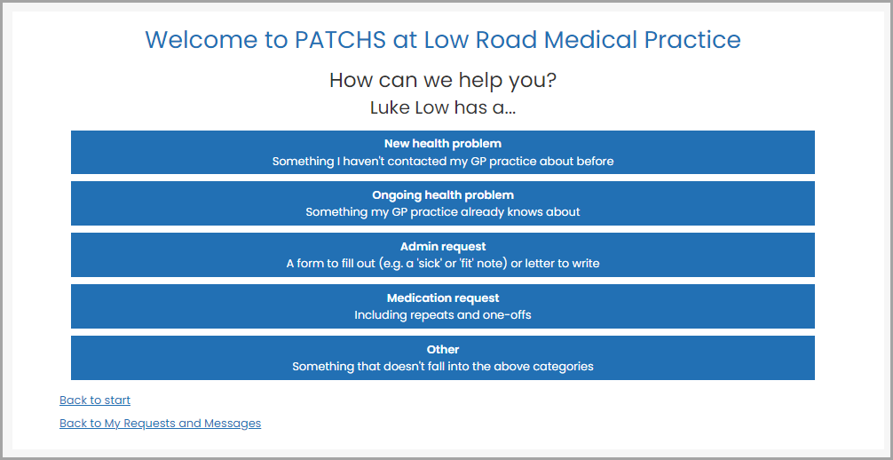

You will then see 3 warning messages:

* Emergency warning - you need to confirm that you are not potentially experiencing a medical emergency. Patchs cannot be used for this purpose because the GP practice will be unable to respond quickly enough in this situation.

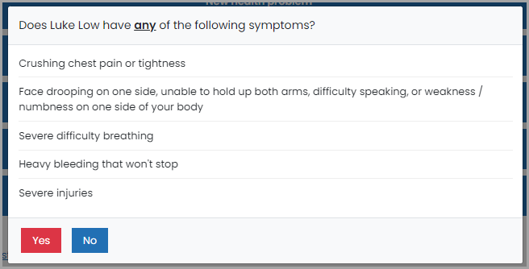

* Confirm details warning - this is to ensure your contact information is up to date so the GP practice can respond to you.

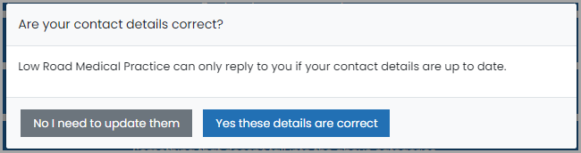

* General information warning - this gives you guidance on what to expect while submitting a Patchs request including how long you have to submit your request.

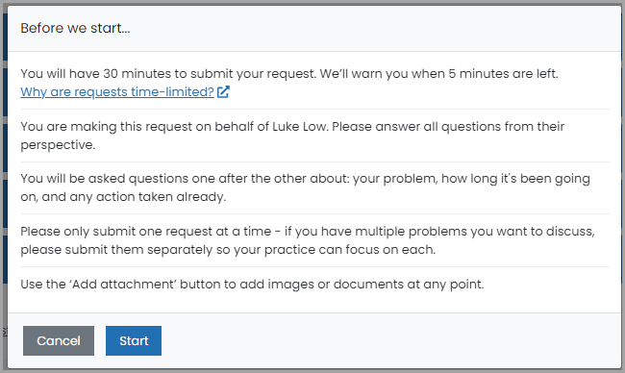

To continue, click on the blue **Start** button.

You will then be taken to the Patchs chatbot, where you will be asked a few simple questions to help your GP understand more about the person you care for's request.

**Please note that the information you submit should be for the person you are caring for and not for yourself**

Answer each question in turn using the **Next**button when each response is complete.

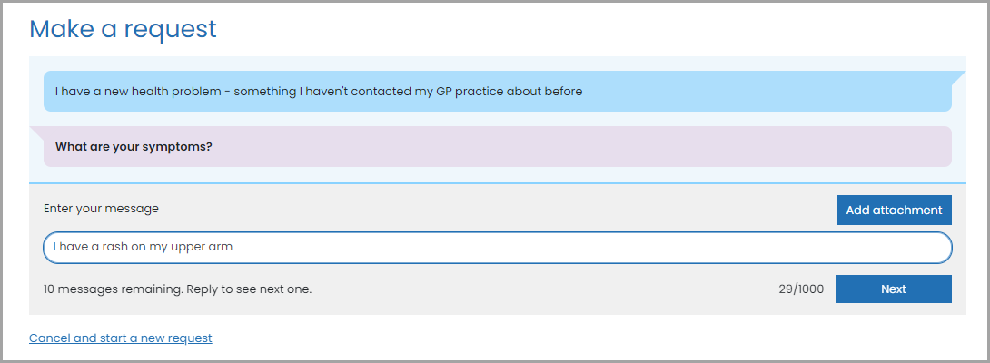

*Please note the chatbot provides fixed questions/responses. It is not a human or an Artificial Intelligence Agent responding.*

An **Edit** button is shown alongside each response:  
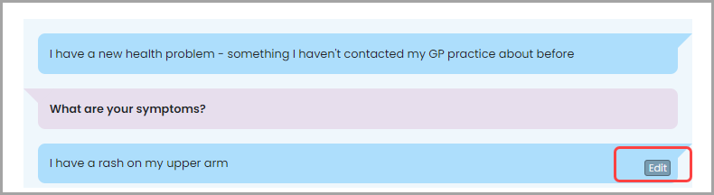

Clicking the **Edit** button allows you to edit your individual responses from within the chatbot:

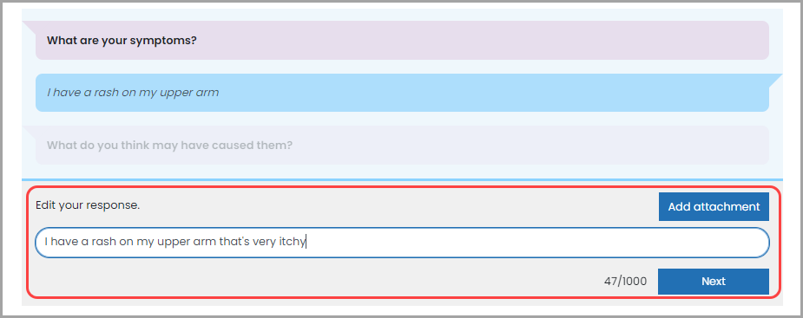

You can use the **Attach**button alongside the text box to add an image to your response.

This loads the **Attach Image or document**box where you can select an image or file to upload.

You should only upload sensitive images if you are asked to do so by your GP.

If it is a sensitive image, you can mark it as such.

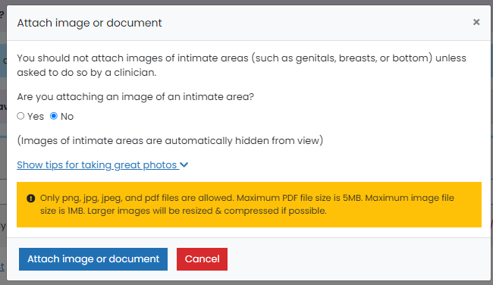

When you have answered and edited all your responses you will be asked to confirm your responses.

Clicking **Next** means that you agree for them to be added to your GP record.  
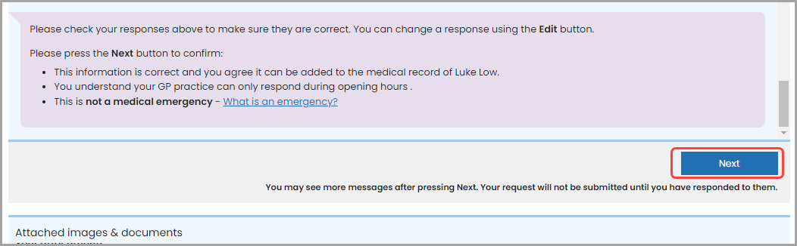

Click the **Next**button to send your request to the practice.  
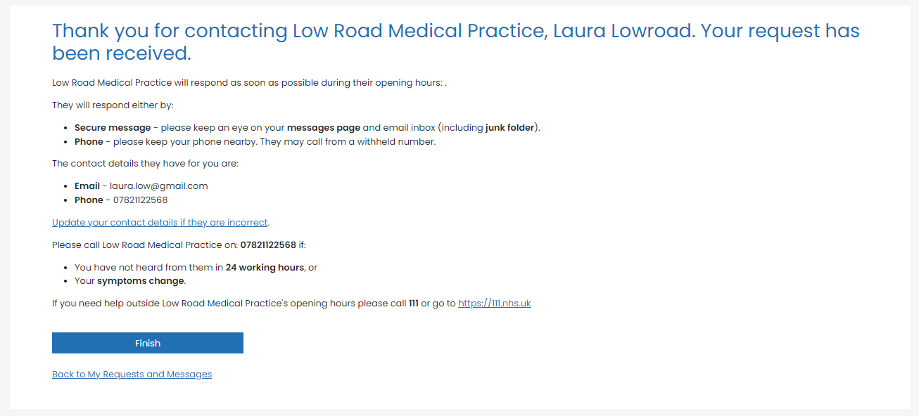

A **confirmation email** will be sent to you and to your GP practice, so that they can respond to your request.

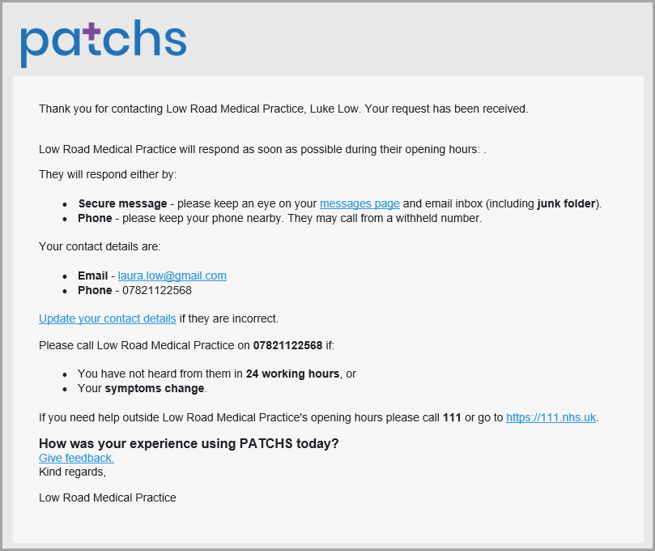

You will then be invited to enter feedback on your experience of Patchs and your GP practice.

This helps us improve the service and identify if there are any problems.

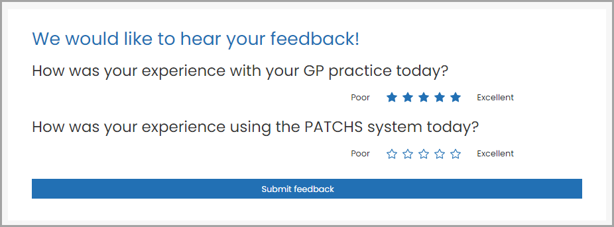

If you want to check on the progress of the request, or you need to respond to a follow-up question sent to you from your practice, you can click the **My Requests & Messages**link at the top of the page.

On this page you will see a list of any past requests. You can open a request by clicking the **View**button next to the relevant request.

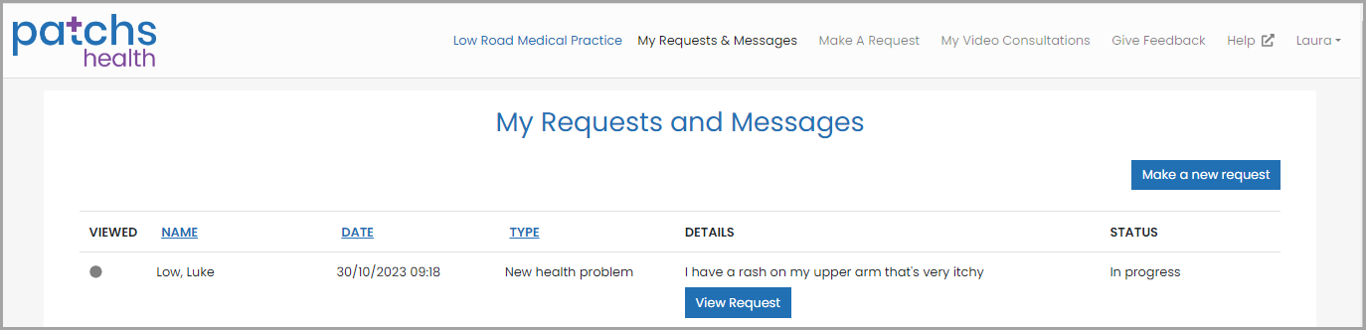

Clicking **View Request** will display your conversation with the practice. You can respond to follow-up questions if you have been requested to do so.