# Registering for PATCHS with a PATCHS Account

In this article we cover how to register for a PATCHS account. There are many benefits for you creating a PATCHS account, including:

* Not having to keep entering your details each time you use PATCHS.
* Your medical information being safer because its password protected.
* Being able to track the progress of your requests.
* Easily seeing if your GP practice is trying to contact you.
* Viewing past conversations you've had with your GP practice
* Being able to submit requests on behalf of people you care for

Having an account also makes it easier for your GP practice because they don't have to check your details each time you submit a new request.

## Registering for a PATCHS Account

This section explains how you can register for PATCHS as a patient.

1. Follow the PATCHS link from your practice’s website - the screenshot below shows an example from the Langworthy Medical Practice - to the **PATCHS Landing** page.

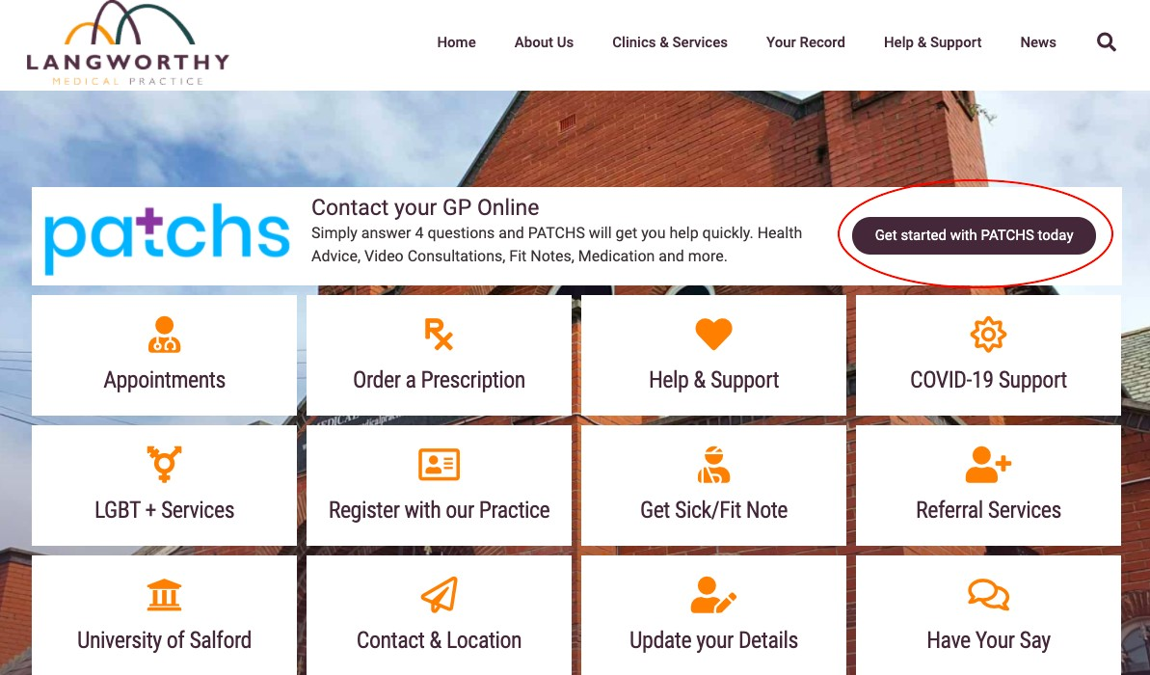

1. 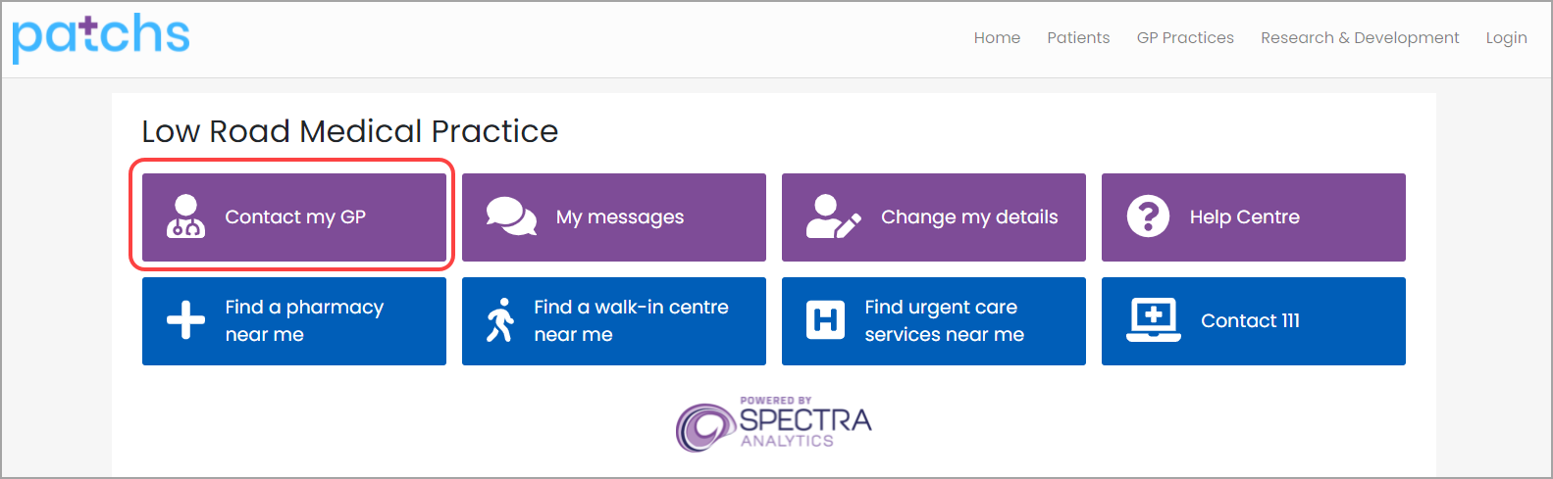Then click on the **Contact my GP** button to take you to the **PATCHS Login** page.
2. If NHS login is available at your practice you can register with PATCHS or with [NHS](https://help.patchs.ai/hc/en-gb/articles/4928795948311-Registering-for-PATCHS-with-NHS-login) [login.](https://help.patchs.ai/hc/en-gb/articles/4928795948311-Registering-for-PATCHS-with-NHS-login)

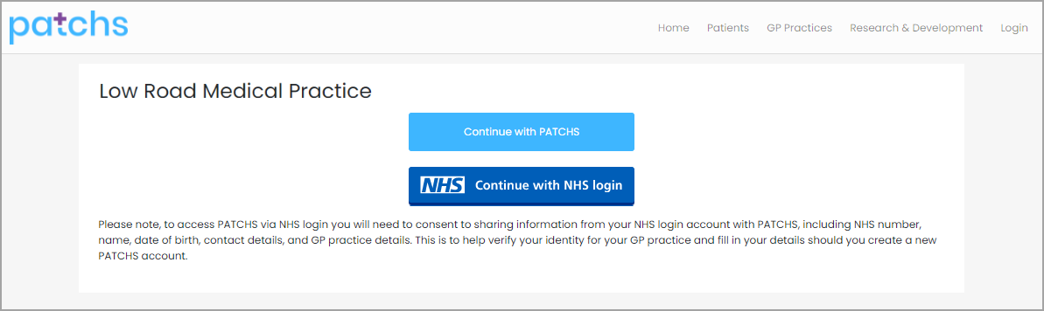To find out how to register for PATCHS with NHS Login read the [article.](https://help.patchs.ai/hc/en-gb/articles/4928795948311)

1. To register with PATCHS you should click **Continue with PATCHS** and you will be taken to the PATCHS login page where you can should click on the **Register as a patient**

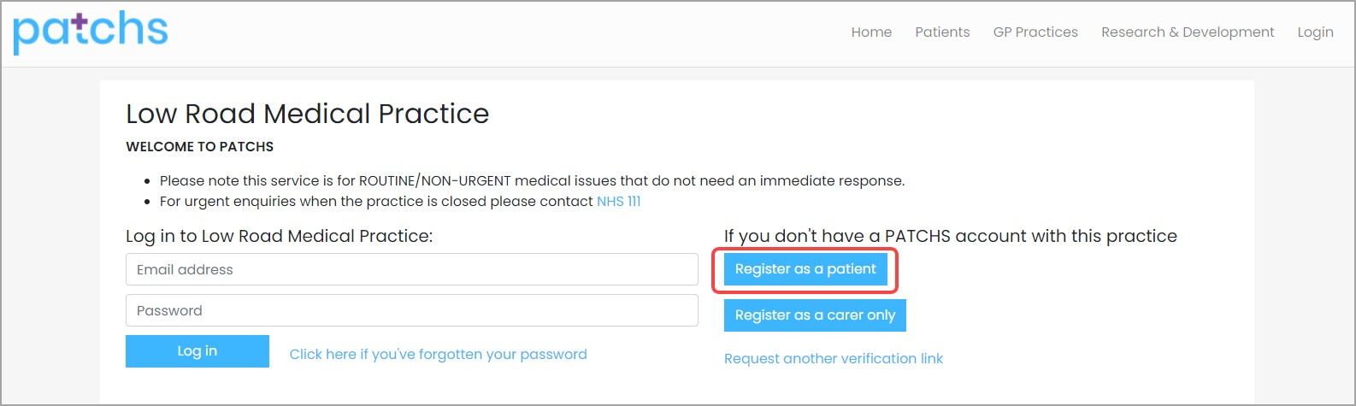button and you will be taken to the PATCHS **Registration** page.

1. To register, you need to click on the **Patient End User License Agreement** link and read the information. Then confirm you:
   * **have read, understood and agree to the terms and conditions** (1st tick box).
   * **are aged 16 years or over** (2nd tick box)

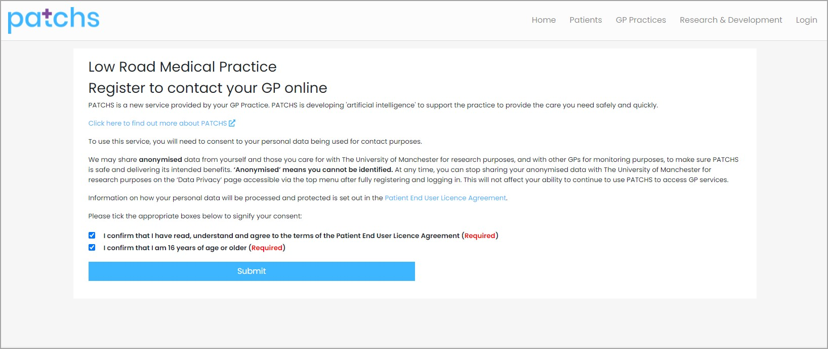

Then click the **Submit** button.

1. 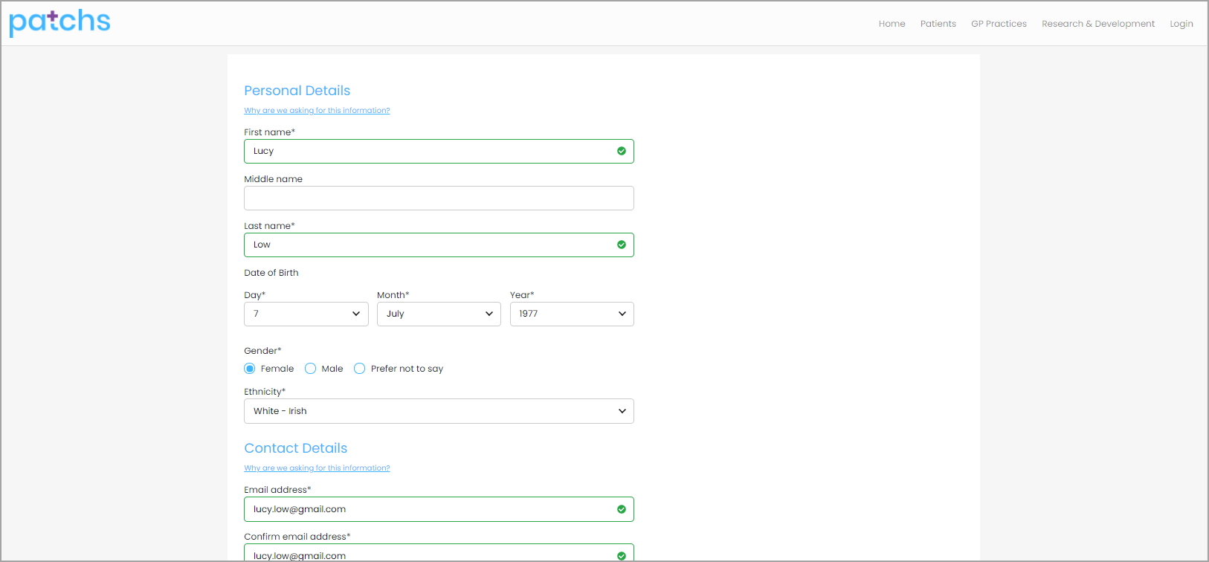This will take you to the **Personal Details** page where you can enter your details.
2. The **Register Button** will validate all mandatory information before submitting your registration request. Any problems with your registration details will be highlighted for correction.

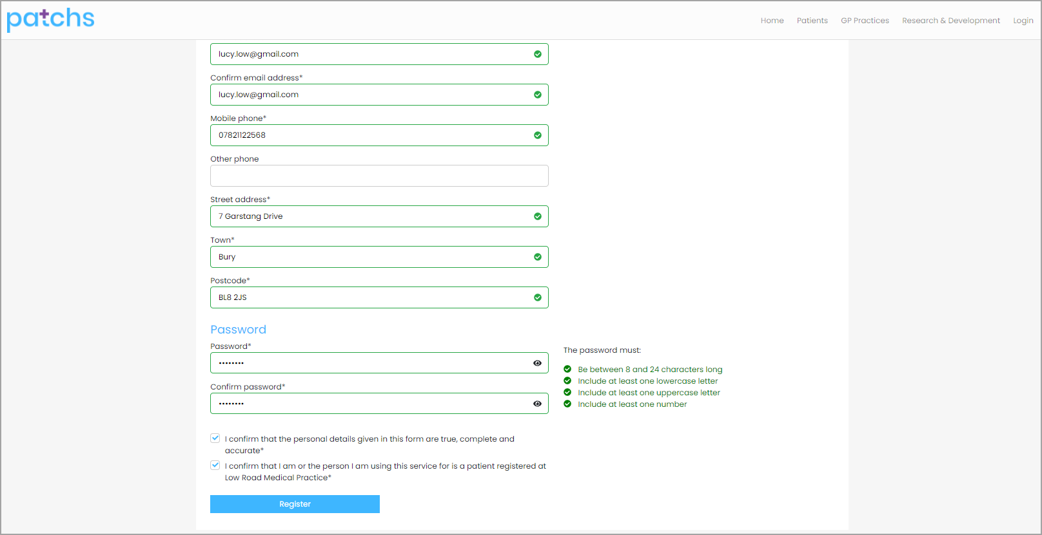Please note you must be aged over 16 to register to use PATCHS.

1. Following successful validation and submission, you will be taken to the **Registration Acknowledgement** page.

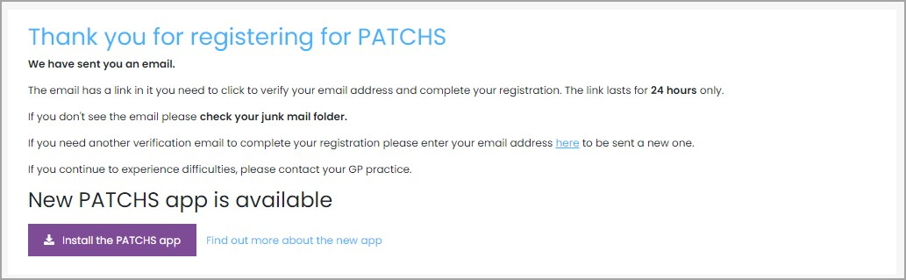

1. You will now receive an email from PATCHS that contains a **'registration completion' link**. (If you don’t receive the email within 5 minutes please check you Junk email folder.

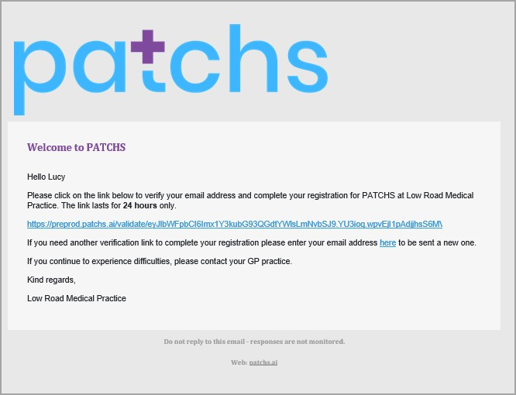If it's not there, please try to register again and check your email address is correct).

1. Clicking on the link will complete the registration and allow you to submit a request to your practice.

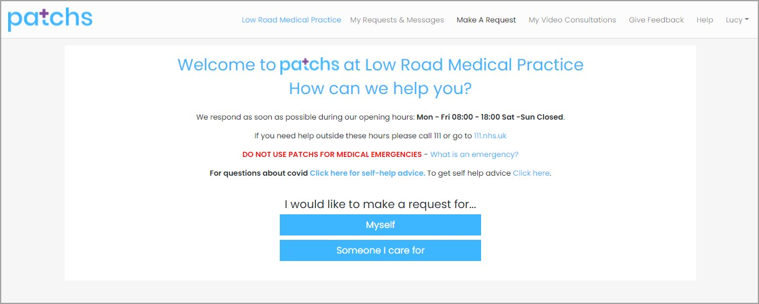

# Registering for PATCHS with NHS login

In this article we cover how to register for PATCHS using the NHS Login

## As a new PATCHS user

When you click on the Contact my GP button from your practice's welcome page you'll be taken to a page where you can Continue with PATCHS or Continue with NHS login.

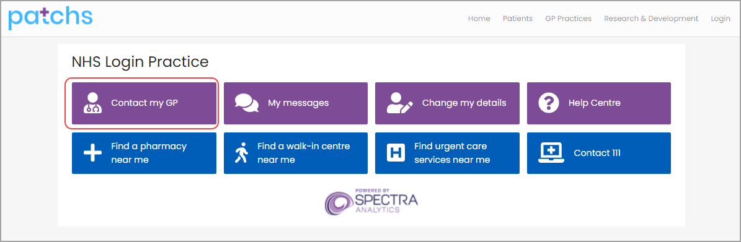

If you're new to PATCHS and would like to access PATCHS with NHS login you should click on the Continue with NHS login button (you can find out more about NHS login [here](https://help.login.nhs.uk/setupnhslogin/#what-is-nhs-login%3F)). [If you do not see this button it is because your GP practice has not enabled NHS Login access].

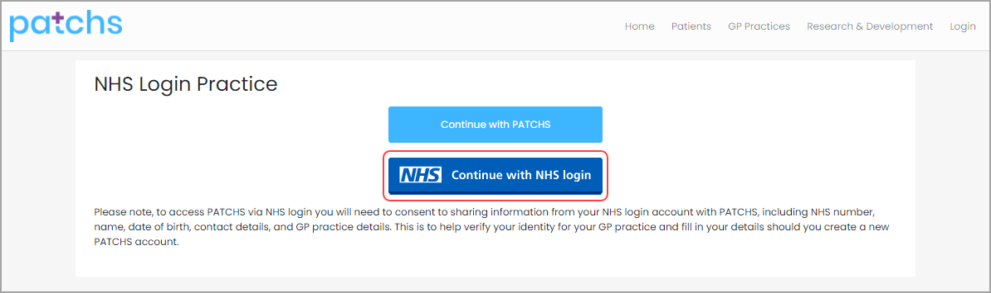

This will take you to NHS login, where where you will sign up or sign into NHS login.

You will then return to PATCHS to Register a new PATCHS account to link to your NHS login.

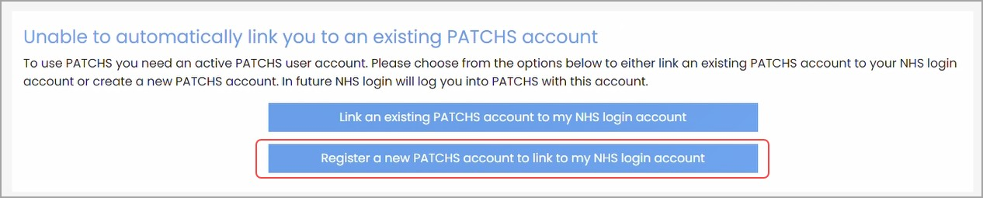

* 1. 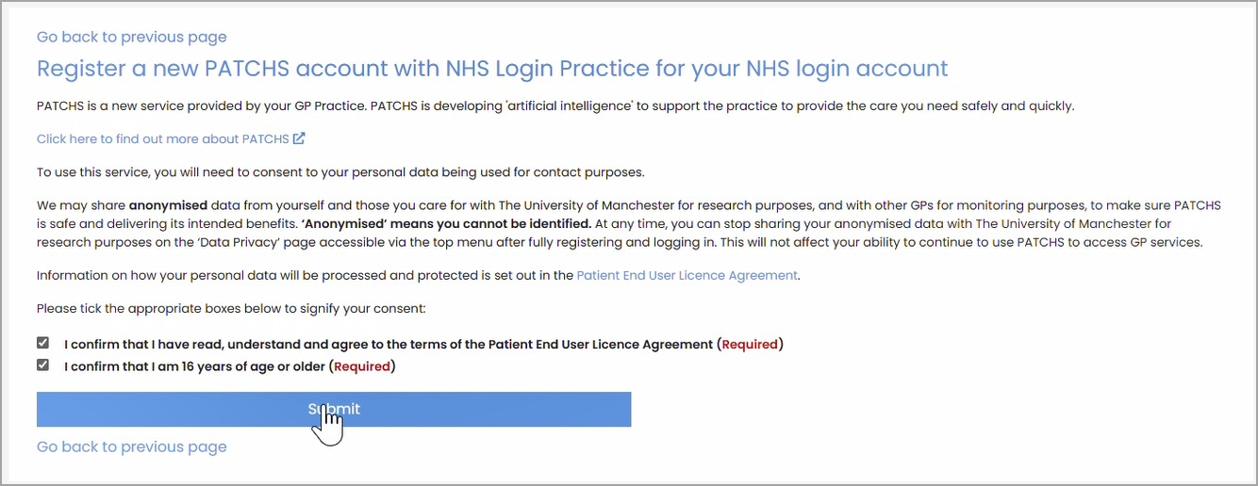**Read and agree to Patient EULA**
  2. 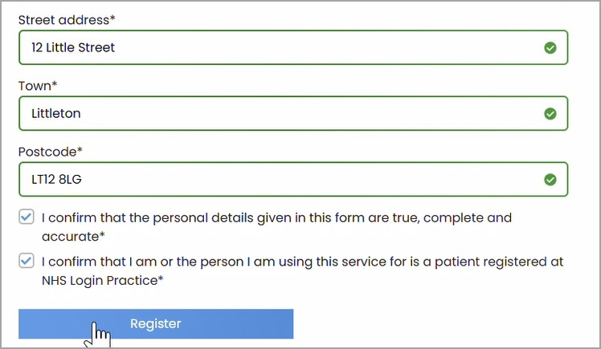**Enter additional demographic details and Register**
  3. **Verify your PATCHS registration**

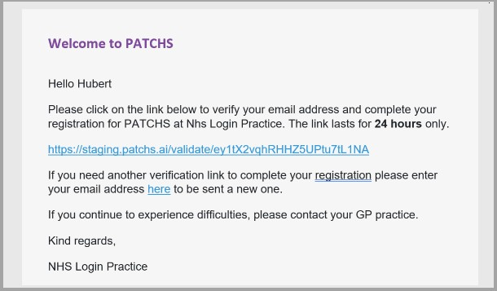

* 1. 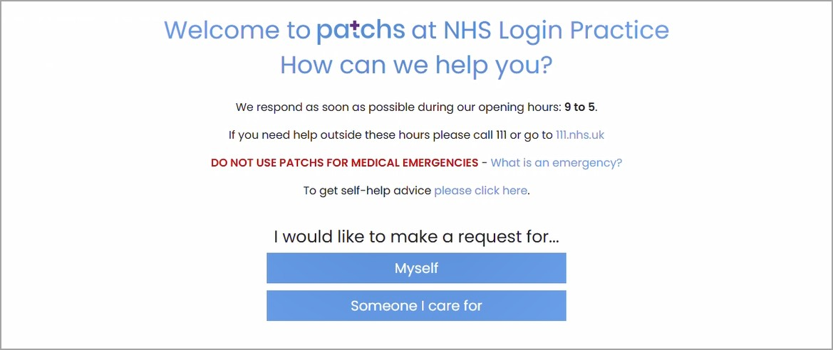**And you will then be able to request help from your practice**

## As an existing PATCHS user

When you click on the Contact my GP button from your practice's welcome page you'll be taken to a page where you can Continue with PATCHS or Continue with NHS login.



If you're an existing PATCHS user who would now like to access PATCHS with NHS login you should click on the Continue with NHS login button (you can find out more about

NHS login [here](https://help.login.nhs.uk/setupnhslogin/#what-is-nhs-login%3F)).



This will take you to NHS login, where where you will sign up or sign into NHS login.

You will then return to PATCHS to Link an existing PATCHS account to your NHS login account.

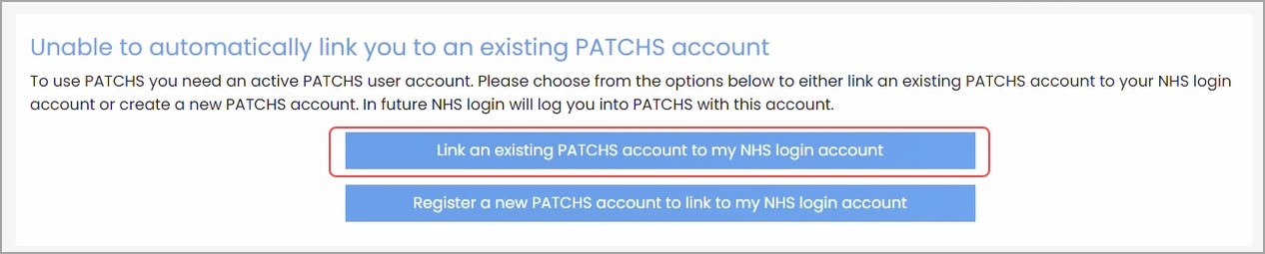

1. 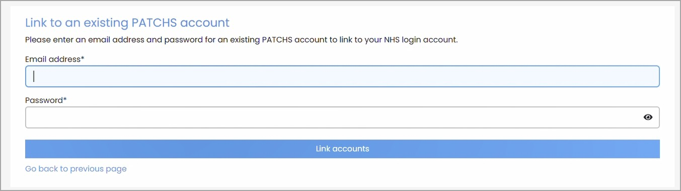**Confirm PATCHS email address and password**
2. **And you will then be able to request help from your practice**

