**Registering for Patchs**

There are 2 main ways to access Patchs:

1. create an individual Patchs account (Option 1)
2. create a Patchs account as a carer for someone else (Option 2)

**Option 1: Creating an individual Patchs Account**

This section explains how you can register for Patchs as a patient.

Follow the Patchs link from your practice’s website. This will usually be on the homepage and will look like one of the below images:

  

Once you have clicked on the Patchs link, you will be taken to the **Patchs Landing page**. On this page, click the **Contact my GP practice**button

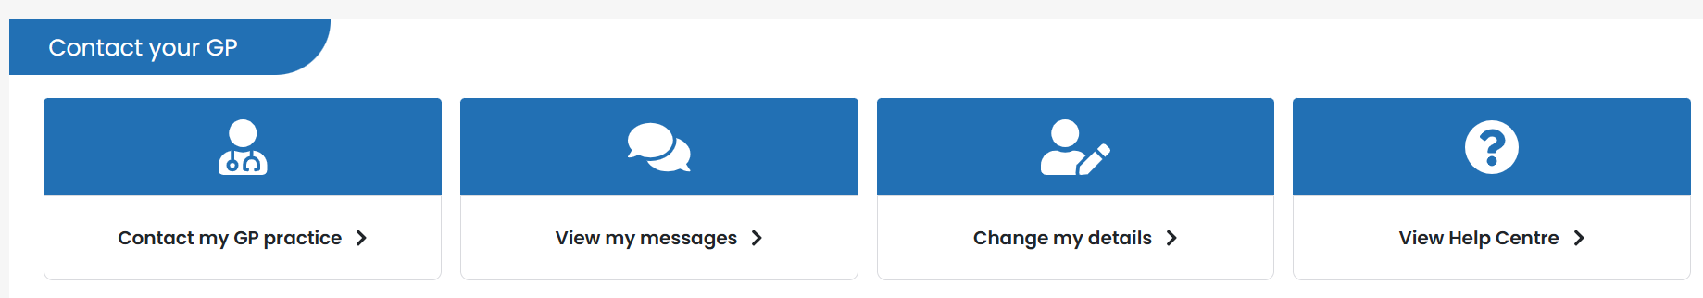

You will now be taken to the **Patchs Login**page.

If NHS login has been made available at your practice, you will see two buttons, one of which says **Continue to NHS login**. Clicking on this button will allow you to register with Patchs using your [NHS login.](https://help.patchs.ai/hc/en-gb/articles/4928795948311-Registering-for-PATCHS-with-NHS-login)For more details about how to do this, please refer to this [article.](https://help.patchs.ai/hc/en-gb/articles/4928795948311)

Otherwise, click on the button which says **Continue with Patchs**:

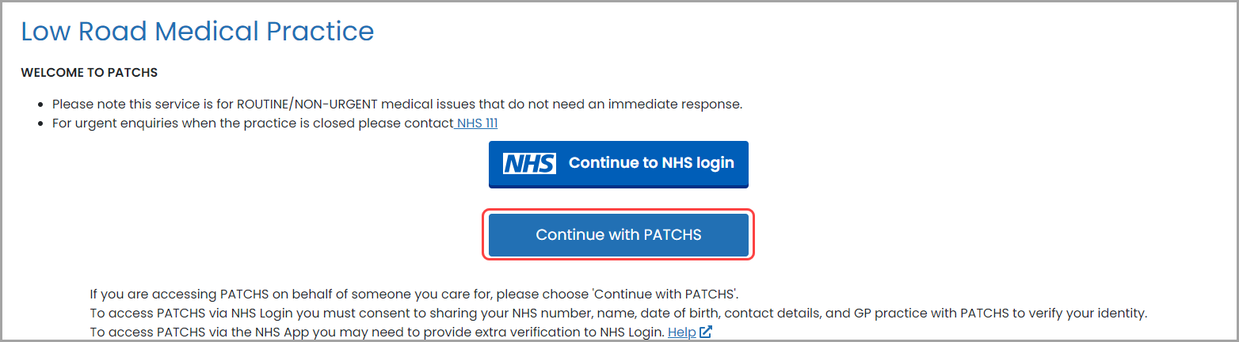

You will be taken to the **Patchs login page**, where you should click on the button which says **Create an account as a patient**:

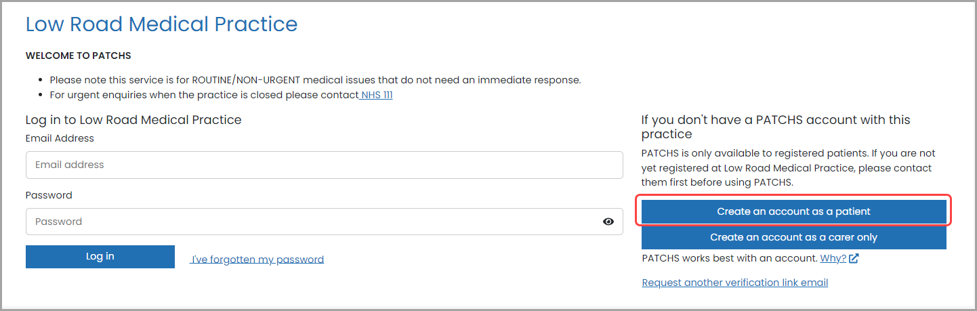

You will be taken to the Patchs **Registration**page.

To register, first you need to click on the **Patient End User License Agreement** link and read the information.

Then click**'Accept and Continue'**.

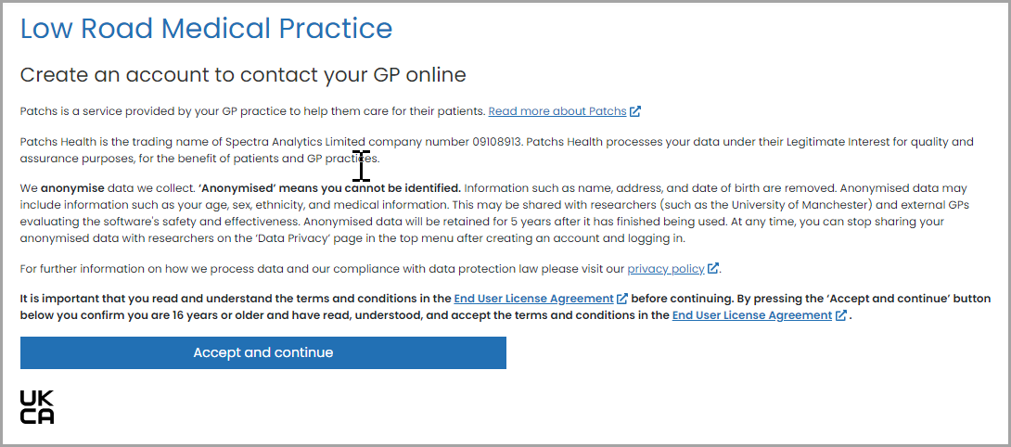

You will now be taken to the **Personal Details**page, where you can enter your information.

Information that is mandatory for you to enter has a * symbol next to it.

***Please note you must be aged over 16 to register to use Patchs.***

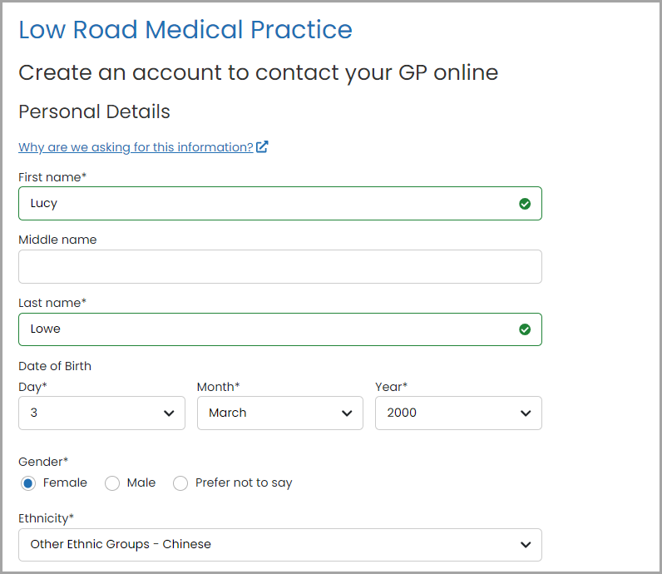

When you have finished, click the **Create an account**button at the bottom of the page.

Doing this will validate all the mandatory information you have entered. Any problems with your registration details will be highlighted for correction.

If there are no problems, your registration request will be submitted.

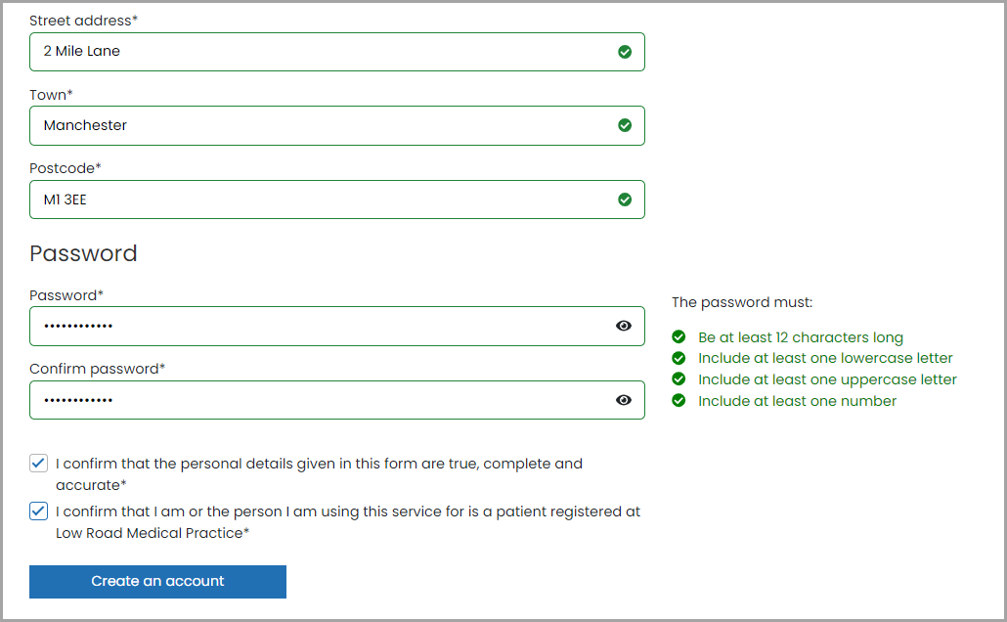

You will now be taken to the **Registration Acknowledgement**page, which informs you that we have sent you an email:

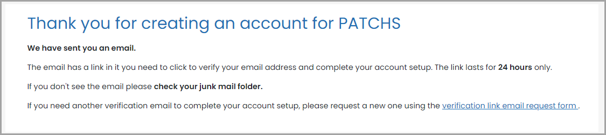

Please look for the email in your email account. It contains a **registration completion**link. You need to click on the link so that we can verify your email address and create your account.

*If you don’t receive the email within 5 minutes please check you Junk email folder. If it's not there, please try to register again and check your email address is correct.*

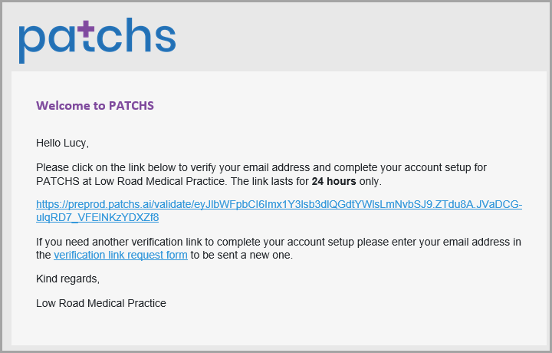

Once you have clicked on the link in the email, your registration will be complete.

You can now submit a request for help from your GP practice:

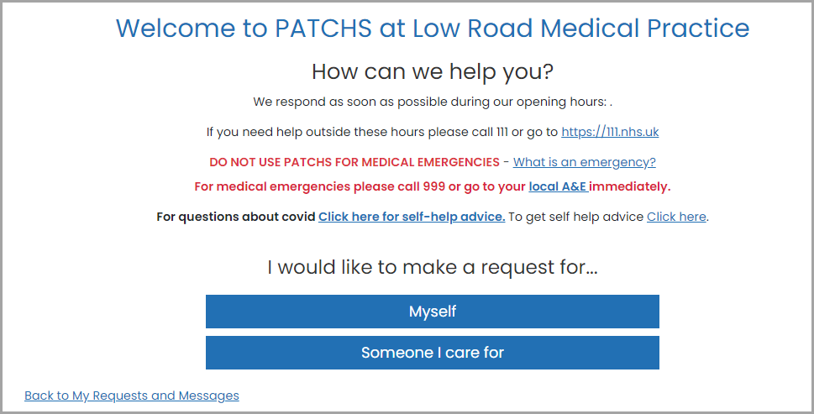

**Option 2: Registering for Patchs as a Carer for Someone Else**

**⚠️ Please note, these instructions are only applicable if the person you care for is registered at a practice other than your own.**

**If you are a patient at the same practice as the person you care for, you should**[**register for Patchs as a patient**](https://help.patchs.ai/hc/en-gb/articles/360058753273)**and then**[**add the patient as someone you care for**](https://help.patchs.ai/hc/en-gb/articles/360056868714)**.**

**If you have a Patchs account at one practice you cannot set up a carer account at another practice using  the same email address.**

Follow the Patchs link from your practice’s website. This will usually be on the homepage and will look like one of the below images:

  

Once you have clicked on the Patchs link, you will be taken to the **Patchs Landing page**. On this page, click the **Contact my GP practice**button



You will now be taken to the **Patchs Login**page. To register for Patchs as a carer, you should click on the **Continue with Patchs**button.



You will be taken to the **Patchs login page**, where you should click on the button which says **Create an account as a carer only**:

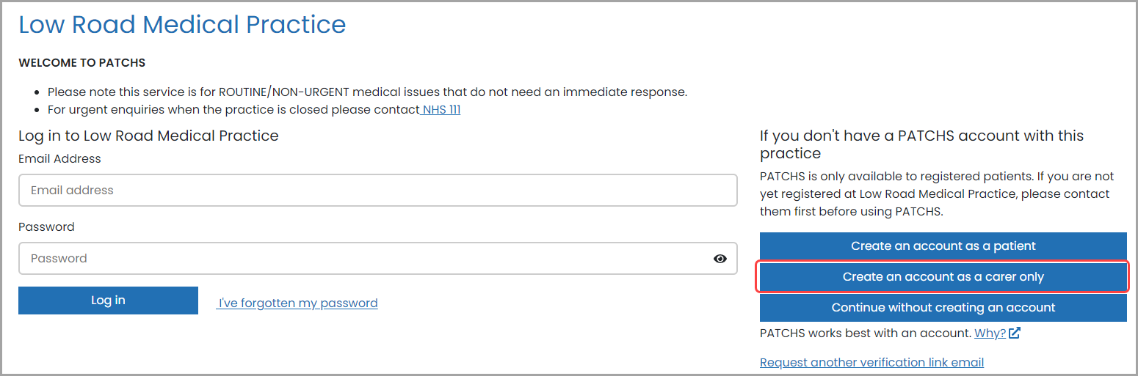

You will be shown the warning below. Please confirm that you are not yourself a patient at the practice by clicking the **Yes** button.

***⚠️  If you are a patient at the same practice as the person you care for, please do not create a carer account. Instead, you should***[***register for Patchs as a patient***](https://help.patchs.ai/hc/en-gb/articles/360058753273)***and then***[***add the patient as someone you care for***](https://help.patchs.ai/hc/en-gb/articles/360056868714)***.***

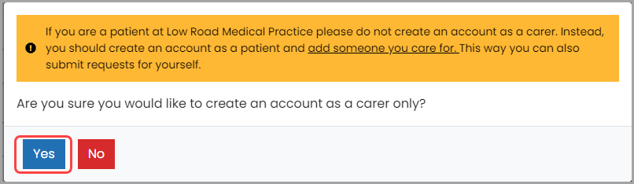

Clicking **Yes** will take you to the Patchs **Registration**page.

To register, first you need to click on the **Patient End User License Agreement** link and read the information.

Then confirm that you: **1.**have read, understood and agree to the terms and conditions (1st tick box).**2.**that you are aged 16 years or over (2nd tick box).

Check the two boxes, and click **Continue**:

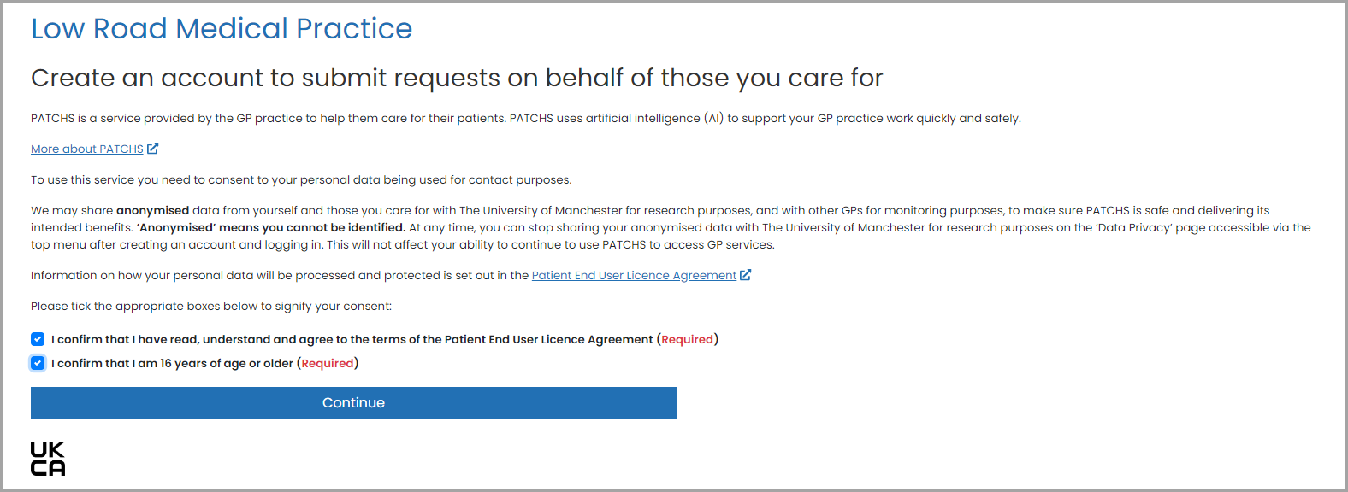

You will now be taken to the **Create an account as a carer**page, where you can enter your details.

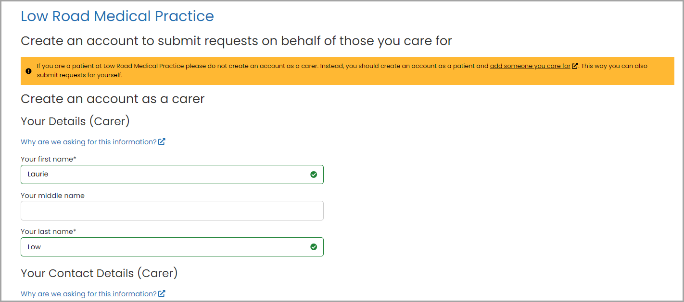

Then, add the details of the person you care for:

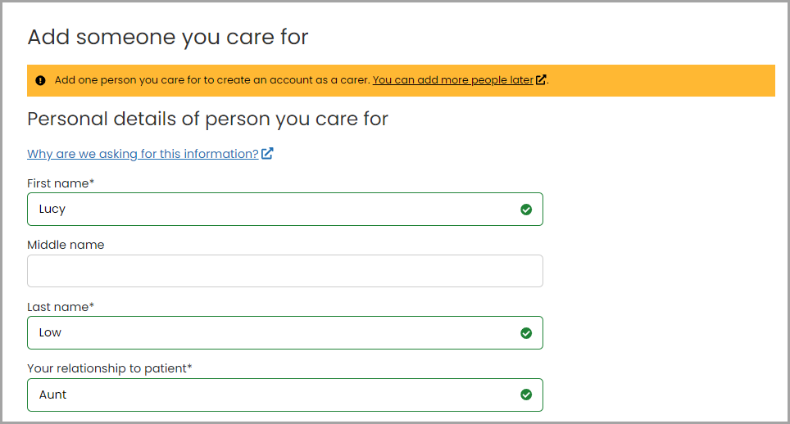

When you have finished, check the three boxes at the bottom of the page to confirm that the information you have provided is accurate, that you have the consent of the person you care for to act on their behalf, and that the person you care for  is registered at the practice. Once you have done this, click the **Create an account**button.

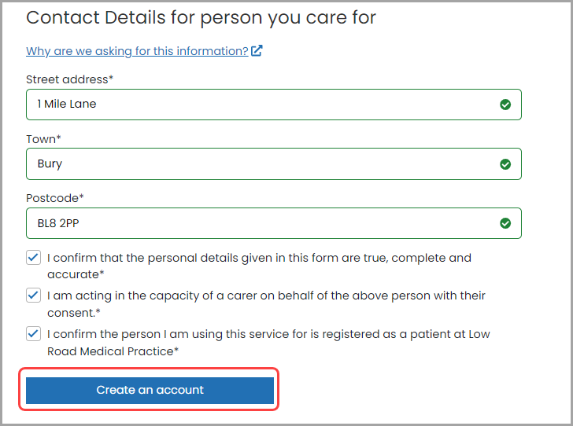

Doing so will validate all the mandatory information you have entered. Any problems with your registration details will be highlighted for correction.

If there are no problems, your registration request will be submitted.

Following successful validation and submission, you will be taken to the **Registration Acknowledgement**page, which informs you that we have sent you an email:

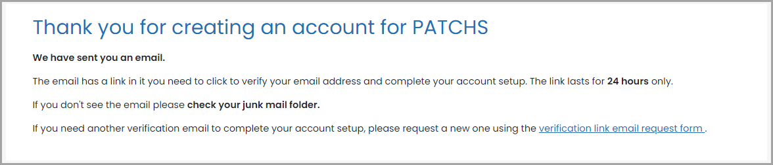

Please look for the email in your email account. It contains a **registration completion**link. You need to click on the link so that we can verify your email address and create your carer account.

*If you don’t receive the email within 5 minutes please check you Junk email folder. If it's not there, please try to register again and check your email address is correct.*

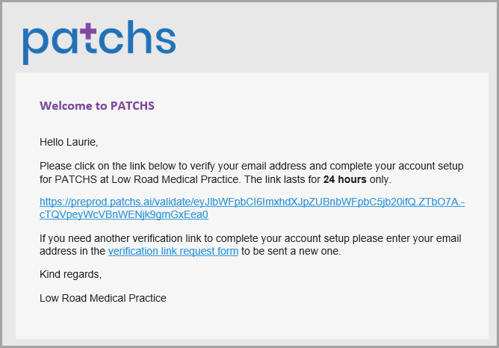

Once you have clicked on the link in the email, your carer registration will be complete.

Log into your new Patchs carer account, where will see the details of the person you care for. Click the **Make A Request** button at the top of your dashboard to begin a new request for help:

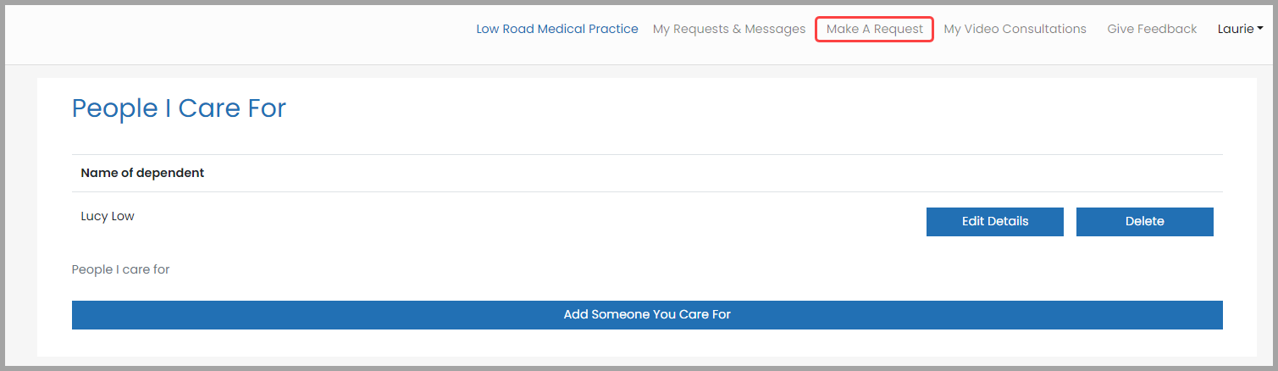

This will load the **How can we help you?**page, where you need to click the **Someone I care for**button to begin a new request for help:  
